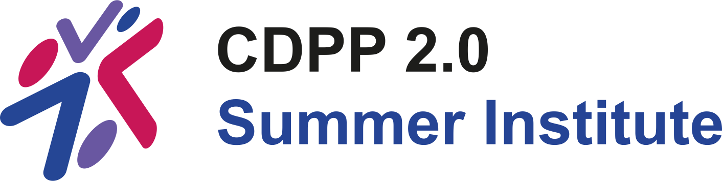

CDPP 2.0 Summer Institute 2025

Proceedings Document

BEST VIEWED IN DESKTOP APP VERSION OF MICROSOFT WORD

Canadian Disability Participation Project (CDPP) 2.0
Summer Institute Planning Committee
www.cdpp2.ca
Email: cdpp2si@queensu.ca
Table of Contents
Summer Institute Welcome Message 7
CDPP 2.0 Success Statement and Core Values 8
Our Commitment to Inclusivity 9
Inclusivity Guidelines 9
Co-creation of Inclusion Agreement 10
Summer Institute’s Focus: Partnership 13
Acknowledgements 14
Learning Objectives for Trainees 16
Program at a Glance 17
Breakout Groups 20
In-Person 20
Online 20
3MT Presentations 21
Tuesday June 10 (Day 1) 21
Wednesday (Day 2) 21
In-Person Meeting Room 8 Seating Plan 22
Attendee Bibliographies & Headshots 23
Albert, Ueli (He/Him) 23
Berrisford, Haley (She/Her) 24
Bob-Manuel, Tamunoemi (He/Him) 25
Capone, Alessia (She/Her) 26
Disimino, Katerina (She/Her) 27
Gee, Cameron (He/Him) 28
Grimes, Alyssa (She/Her) 29
Juan, Owen (He/Him) 30
Locke, Maggie (She/Her) 31
Mahmoudi, Ebrahim (He/Him) 32
Mullan, Marley (She/Her) 33
Naqvi, Zainab (She/Her) 34
Neufeld, Jake (He/Him) 35
Noguchi, Kenneth (He/Him) 36
Purdy, Adam (He/Him) 37
Rassi, Sepehr (He/Him) 38
Silverman, Rayona (She/Her) 39
So, Sofia (She/Her) 40
Szydlowski, Gabriela (She/Her) 41
Tang, Kailan (She/Her) 42
Taylor, Leah (She/Her) 43
Walters, Alexandra (She/Her) 44
Wing, Meredith (She/They) 45
Abstracts 46
Albert, Ueli (He/Him) 46
Berrisford, Haley (She/Her) 48
Bob-Manuel, Tamunoemi (He/Him) 50
Capone, Alessia (She/Her) 52
Disimino, Katerina (She/Her) 54
Gee, Cameron (He/Him) 56
Grimes, Alyssa (She/Her) 58
Juan, Owen (He/Him) 60
Mahmoudi, Ebrahim (He/Him) 62
Locke, Maggie (She/Her) 64
Mullan, Marley (She/Her) 66
Naqvi, Zainab (She/Her) 68
Neufeld, Jake (He/Him) 70
Noguchi, Kenneth (He/Him) 72
Purdy, Adam (He/Him) 74
Rassi, Sepehr (He/Him) 76
Silverman, Rayona (She/Her) 78
So, Sofia (She/Her) 80
Szydlowski, Gabriela (She/Her) 82
Tang, Kailan (She/Her) 84
Taylor, Leah (She/Her) 86
Walters, Alexandra (She/Her) 88
Wing, Meredith (She/They) 90
Jane Arkell Ambassadors 92
Background 92
Guidelines 93
Adjudication 94
Recipients 96
Facilitators 97
Arbour-Nicitopoulos, Kelly (She/Her) 97
Basset-Gunter, Rebecca (She/Her) 98
Gainforth, Heather (She/Her) 99
Amy Latimer-Cheung (She/Her) 100
Leo, Jen (She/Her) 101
Sukhai, Mahadeo (He/Him) 102
Presenters 103
Gainforth, Heather (She/Her) 103
McColl, Mary Ann (She/Her) 104
Nixon, Stephanie (She/Her) 105
Price, Jenson (She/Her) 106
Sukhai, Mahadeo (He/Him) 107
Tomasone, Jenn (She/Her) 108
Planning Committee 109
Gee, Christina (She/Her) 109
Price, Jenson (She/Her) 109
Robinson, Samantha (She/Her) 110
Sukhai, Mahadeo (He/Him) 110
Tomasone, Jenn (She/Her) 111
Van Dornick, Kirsti (She/Her) 111

Summer Institute Welcome Message

The Canadian Disability Participation Project 2.0 (CDPP2) hosted its inaugural Summer Institute from June 10 to June 12, 2025. The event brought together 11 in-person trainees and 12 online trainees, who engaged in enriched discussions on partnered disability research and knowledge mobilization. The Summer Institute was supported by 6 CDPP faculty members who contributed to an inclusive, innovative, and engaging program aimed at advancing quality participation in sport, exercise, and active play for persons experiencing disability in Canada.

This proceedings document includes information to help you navigate the content of the Summer Institute. It provides details about the program, speakers, attendees, and 3MT abstracts, and serves as a record of the event. What follows is an overview of the sessions, discussions, and key learnings.

If you have any follow-up questions or offerings, please contact cdpp2@queensu.ca.

Warm regards,

CDPP 2.0 Summer Institute 2025 Planning Committee

*Please note, a quality improvement evaluation for the 2025 Summer Institute is ongoing. Findings will be added to the proceeding documents once available.

CDPP 2.0 Success Statement and Core Values

The goal of the CDPP 2.0 is to co-create and mobilize new knowledge to improve quality participation in sport, exercise, and active play and optimize outcomes of participation among children, youth, and adults experiencing disability.

In 7 years, we will know our partnership has been successful if physical activity is a quality experience for people with a disability living in Canada. To be successful, we will

Partner: We will meaningfully engage academic partners, community partners and people with lived experience of disability to conduct, disseminate and implement research.

Innovate: We will conduct innovative research generating new knowledge and evidence-based tools and resources to create quality experience in sport, exercise, and play for people with disabilities.

Build Capacity: We will develop competent leaders in quality participation and physical activity research, knowledge translation and practice while valuing the well-being of and ensuring a quality experience for all partnership members.

The core values guiding our work include:
- Contributing to positive impact in our communities
- Prioritizing quality in all we do
- Partnering authentically and respectfully
- Being reflexive and responsive to engage persons least represented in physical activity and disability research and practice.

Our Commitment to Inclusivity

The CDPP 2.0 Summer Institute Planning Committee is committed to providing an inclusive, supportive, and respectful environment for all participants. We strive to lean into CDPP 2.0’s core values to create a space where everyone can engage fully, learn, and contribute. To encourage this environment, we have established Inclusivity Guidelines that all trainees are expected to adhere to while in attendance at the CDPP 2.0 Summer Institute.

Inclusivity Guidelines

- Respect and Professionalism
- All attendees, speakers, and staff will always treat each other with respect and professionalism.
- Everyone is encouraged to contribute during discussion periods. Trainees are expected to engage in open, respectful dialogue and be considerate of differing perspectives, backgrounds, and experiences.
- Inclusive Language and Behaviour
  - Use inclusive language that respects and affirms the identities of all participants.
  - Avoid language or behaviour that could marginalize, stereotype, or exclude others.
  - Recognize the importance of equity and diversity, and work to ensure that all voices are heard and valued.
- Safe and Supportive Environment
  - The CDPP 2.0 Summer Institute is a safe space for all persons in attendance to share ideas, learn, and collaborate. We encourage everyone to create an environment that fosters trust, openness, and mutual respect.
- Accommodations and Accessibility
  - We are committed to making the CDPP 2.0 Summer Institute accessible to all in attendance. If there are accessibility supports (accommodations) we can put in place to ensure your full participation in the CDPP 2.0 Summer Institute, please let us know in advance.

Co-creation of Inclusion Agreement
As part of our commitment to fostering an inclusive environment at the CDPP 2.0's Summer Institute, all attendees took park in co-creating an Inclusion Agreement using Mural, a collaborative digital platform. This interactive process ensured that every participant had a voice in shaping the shared norms and expectations that guided our time together.
In Mural, attendees were asked to respond to two prompts:
- Please offer two actions that would help facilitate a safe, welcoming, and inclusive learning space for you.
- Please offer two actions that would impede you from feeling safe, welcomed, and included.
By contributing to and reviewing each other’s input, participants helped define what inclusion looks like in practice, grounded in lived experience and mutual respect. This co-creation process was essential to centering diverse perspectives and fostering a learning environment that was safe, welcoming, and inclusive for all.
Collectively, the trainees who attended the 2025 Summer Institute offered the following ideas for fostering inclusion at the Summer Institute. The sub-bullet points represent how the planning committee responded to the ideas.
- Share materials in advance
  - A draft proceedings documents was assembled and distributed the week before the Summer Institute.
  - All trainees were given access to a SharePoint page which housed all accessible materials used on each day of the Summer Institute (e.g., presentation slides, templates for activities, handouts, resources, breakout group instructions).
- Offer varied modes of content delivery
  - The program included a range of didactic and active learning opportunities. Delivery modes included presentations, group discussions, individual activities and reflections, breakout groups, and “speed dating” to discuss research ideas.
- Autonomous participation
  - Trainees were encouraged to share as they felt comfortable and welcomed to ask questions or revisit ideas at any point in the program.
- Offer opportunities to foster relationships
  - The opening of the Summer Institute included a roundtable introduction, where trainees were asked to introduce themselves and respond to an icebreaker.
  - Four breakout group sessions spread over the program allowed for small group work and networking.
  - “Speed dating” after dinner on both evenings offered opportunity for one-on-one conversations between trainees and faculty members.
  - Reflections and check-in points were built into the program to offer chances to hear diverse perspectives from attendees about the content being discussed.
  - Break time offered informal opportunities for networking.
- Offer breaks and clear expectations of break time.
  - Snack and meal breaks were interspersed throughout the program. A longer break was offered in the afternoon each day before dinner.
  - The expectations for break time were communicated at the start of the Summer Institute. These included: rest and recharge (in whatever form suited the trainee), refuel (food), movement (although movement was encouraged throughout the program), networking and building relationships.
  - The planning committee aimed to squeeze in as much as they could into our time together. Trainees were encouraged to take longer or additional breaks than those built into the program, at their own discretion.

As part of the presentation of the inclusion agreement at the opening of the Summer Institute, it was made clear that inclusivity is a journey, and not an endpoint. Some of the individuals (trainees, staff, and faculty alike) were more experienced with fostering inclusive environments than others, and that the planning committee, faculty and presenters are learning alongside the trainees in this space. We encouraged trainees to come to talk to us or to fill out an anonymous feedback survey at any point during the program if there was anything else we could do to make their experience a better one.

Summer Institute’s Focus: Partnership
The CDPP 2.0 Summer Institute was centered on the theme of partnership—recognizing that meaningful progress in disability inclusion relies on strong, collaborative relationships. This year’s Institute emphasized building and strengthening partnerships between researchers, community organizations, and others engaged in advancing accessibility and equity.
Participants explored how inclusive, reciprocal partnerships can foster innovation, support evidence-informed decision-making, and drive systems-level change. Through dialogue, reflection, and skill-building, the Summer Institute supported attendees in developing the tools and relationships needed to work together effectively across sectors and roles—grounded in respect, trust, and a shared commitment to enhancing participation for persons with disabilities.

Acknowledgements
The Canadian Disability Participation Project 2.0’s Summer Institute was made possible through the generous support and collaboration of our partners.
We gratefully acknowledge the Social Sciences and Humanities Research Council (SSHRC) for their vital funding and continued support of CDPP 2.0. Their commitment to inclusive, community-engaged research has been instrumental in advancing the goals of this initiative. We also extend our sincere thanks to Queen’s University for co-funding this event and for providing a welcoming space that fosters dialogue, learning, and connection.

We would like to express our deep appreciation to:
- Our Working Group Members, who helped us shape the initial vision of the Summer Institute and offered us guidance throughout the planning process: Marcia Finlayson, David Legg, and Sarah Donkers.
- The applicant Review Committee, who carefully, thoughtfully, and promptly reviewed the applications submitted for this year’s event: Marcia Finlayson, David Legg, Sarah Donkers, Kathleen Martin Ginis, Mahadeo Sukhai, and Jenn Tomasone.
- Our Keynote Presenter, Heather Gainforth, whose thoughtful guidance helped shape the program and quality improvement evaluation.
- Our Guest Presenters, Stephanie Nixon and Mary Ann McColl, who graciously shared their time and expertise in expanding the perspectives shared in this year’s program.
- Our Breakout Group Facilitators, whose leadership and care help create an engaging, inclusive environment throughout the Summer Institute: Kelly Arbour-Nicitopoulos, Rebecca Bassett-Gunter, Jen Leo, Heather Gainforth, Amy Latimer-Cheung, and Mahadeo Sukhai.
- Our Planning Committee, who has worked tirelessly for over a year to put together an inclusive, innovative, and engaging event: Jenson Price, Samantha Robinson, Kirsti Van Dornick, Mahadeo Sukhai, and Jenn Tomasone.
- Our Logistics Coordinator, Kirsti Van Dornick, for keeping our planning on track and for being the front-line contact for applicants and attendees.
- Our CDPP 2.0 Manager of Operations and Partnership, Erika Beresford-Kroeger, for managing our contracts, budget, and reimbursement procedures, and constant support for this event.
- Our Summer Intern, Christina Gee, for all the behind the scenes help with pulling together documents, organizing files, checking slides for accessibility, and never-ending enthusiasm for stepping up to complete any task.
- Our Partner at the Active Living Alliance for Canadians with a Disability, Christa Costas-Bradstreet, for her support of the Jane Arkell Ambassador designation.
- The Staff at the Donald Gordon Centre, for working with us to ensure a seamless and inclusive experience for everyone at the Summer Institute.
Together, all contributions created a collaborative and equitable space that supported the mission of disability participation and inclusion in Canada.

Learning Objectives for Trainees

After completion of the CDPP 2.0 Summer Institute 2025, trainees will be able to:
- Describe processes used to initiate and maintain research partnerships
- Apply principles of equity, diversity, inclusion, accessibility, and social justice in research partnerships
- Apply the iKT Guiding Principles and associated strategies to real-world case scenarios of partnership challenges

To facilitate success, trainees had the opportunity to:
- Reflect on their own positionality within partnered research and knowledge mobilization
- Reflect on the science and art of partnership, and how it applies to their own work
- Build and strengthen relationships with trainees and members of the CDPP partnership
- Identify where interventions of further support are needed for partnership within the CDPP

Program at a Glance

Day 1: Tuesday June 10, 2025
Time | Activity
7:00-8:30 am | Breakfast (In-person)
8:30-9:00 am | Welcome to the CDPP 2.0 Summer Institute!
9:00-9:30 am | Introductions, Pre-learning Reflection, and Goal Setting
9:30-10:15 am | Group Reflection with Dr. Mahadeo A. Sukhai
10:15-10:30 am | Break
10:30-11:00 am | Individual Activity with Dr. Jenson Price
11:00-11:45 am | Keynote Presentation Part 1: Rising Tides with Dr. Heather L. Gainforth
11:45-12:30 pm | Deep Thought Discussion with Dr. Mahadeo A. Sukhai
12:30-1:30 pm | Lunch Break
1:30-3:00 pm | Presentation: Where are the Coins? Power and Positionality in Partnerships with Dr. Stephanie A. Nixon
3:00-3:30 pm | Break
3:30-3:45 pm | Introduction to Group Case Scenarios
3:45-4:30 pm | Small Group Breakout Work: Case Scenarios
4:30-6:00 pm | Break (Active option (in-person): Stroll to waterfront)
6:00-7:00 pm | Dinner Break
7:00-8:00 pm | 3-Minute-Theses & Speed Dating

Day 2: Wednesday June 11, 2025
Time | Activity
7:00-8:30 am | Breakfast (In-person)
8:30-8:45 am | Day 2 Welcome and Overview
8:45-9:30 am | Large Group Discussion: Knowledge Users
9:30-10:00 am | Small Group Breakout Work: Revisit Case Scenarios
10:00-10:15 am | Break
10:15-11:00 am | Presentation: Partnering with Policymakers with Dr. Mary Ann McColl
11:00-12:00 pm | Small Group Breakout Work: Policy & Case Scenarios
12:00-1:00 pm | Lunch Break
1:00-1:30 pm | Large Group Debrief: Partnering with Policymakers
1:30-2:15 pm | Keynote Presentation Part 2: Navigating Currents with Dr. Heather L. Gainforth
2:15-4:00 pm | Small Group Breakout Work: iKT Guiding Principles & Case Scenarios
4:00-5:30 pm | Break (Active option (in-person): Outdoor yoga)
5:30-6:30 pm | Dinner Break
6:30-7:30 pm | 3-Minute-Theses & Speed Dating

Day 3: Thursday June 12, 2025
Time | Activity
7:00-8:30 am | Breakfast (In-person)
8:30-8:45 am | Day 3 Welcome and Recapitulation of the CDPP 2.0 Summer Institute
8:45-10:00 am | Large Group Discussion/Presentations: Take up iKT Guiding Principles in Case Scenarios
10:00-10:15 am | Break
10:15-10:30 am | Individual Activity: Revisit Goal for Summer Institute & Postcard Writing For 6 Months into the Future
10:30-11:15 am | Roundtable Discussion: Final Thoughts from Each Attendee
11:15-11:30 am | Evaluation: Survey Completion
11:30 am | Send-off (in person: boxed lunches)

Breakout Groups

In-Person  Sport  - Alessia Capone  - Marley Mullan  - Adam Purdy  - Haley Berrisford  - Facilitator: Amy Latimer-Cheung  Exercise  - Tamunoemi Bob-Manuel  - Leah Taylor  - Alexandra Walters  - Zainab Naqvi  - Facilitator: Mahadeo Sukhai  Play  - Alyssa Grimes  - Maggie Locke  - Rayona Silverman  - Meredith Wing  - Facilitator: Heather Gainforth | Online  Sport  - Ueli Albert  - Jake Neufeld  - Gabriella Szydlowski  - Cameron Gee  - Facilitator: Rebecca Bassett-Gunter  Exercise  - Katie Disimino  - Sofia So  - Kenneth Noguchi  - Facilitator: Jen Leo  Play  - Sepehr Rassi  - Kailan Tang  - Owen Juan  - Ebrahim Mahmoudi  - Facilitator: Kelly Arbour-Nicitopoulos

3MT Presentations

Tuesday June 10 (Day 1)

In-Person  - Alexandra Walters  - Marley Mullan  - Leah Taylor  - Alyssa Grimes  - Zainab Naqvi  - Adam Purdy  Speed daters: Day 2 presenters + Mahadeo | Online  - Ueli Albert  - Katie Disimino  - Sep Rassi  - Sofia So  - Owen Juan  Speed daters: Day 2 presenters + Heather, Amy

Wednesday (Day 2)

In-Person  - Tamunoemi Bob-Manuel  - Meredith Wing  - Haley Berrisford  - Maggie Locke  - Alessia Capone  - Rayona Silverman  Speed daters: Day 1 presenters + Jenson | Online  - Kailan Tang  - Cameron Gee  - Kenny Noguchi  - Gabriela Szydlowski  - Ebrahim Mahmoudi  - Jake Neufeld  Speed daters: Day 1 presenters + Heather, Amy

In-Person Meeting Room 8 Seating Plan

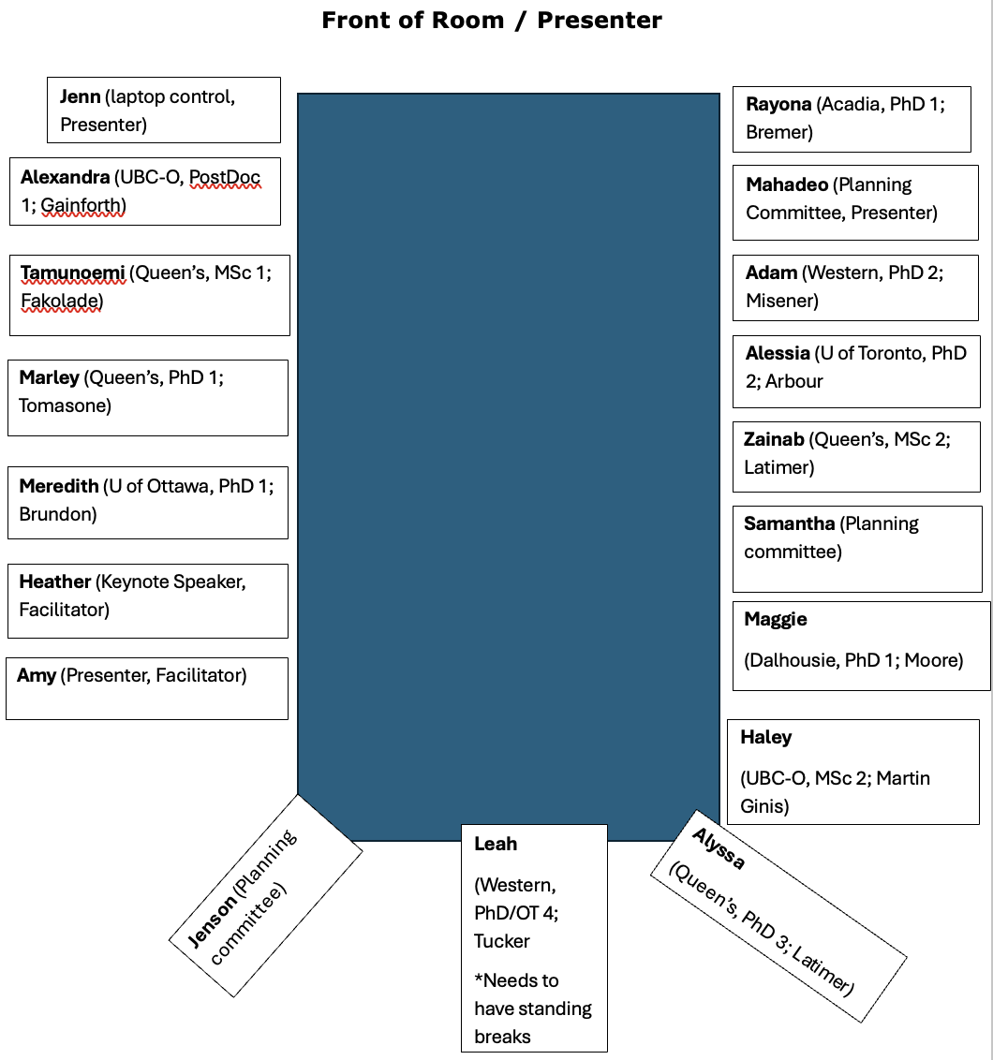

Attendee Bibliographies & Headshots

Albert, Ueli (He/Him)
Online attendee

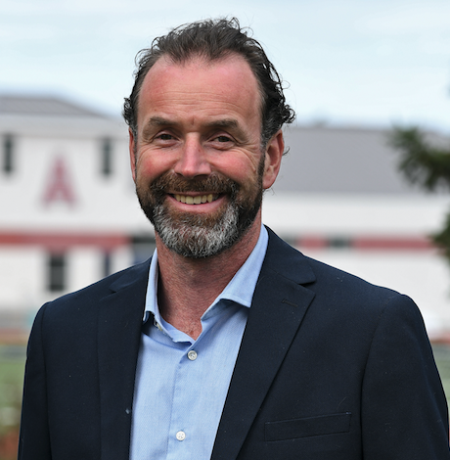 | Hi, my name is Ueli Albert and I’m a PhD candidate in Education at Acadia University. I’m working with Dr. Emily Bremer, focusing my research on what makes parasport experiences meaningful and high-quality for athletes with a disability. I’m excited to attend the CDPP 2.0 Summer Institute to connect with others who care about disability research and inclusive practices. I’m really looking forward to learning, sharing ideas, and gaining new perspectives that will help shape both my research and the way I support athletes and coaches in the real world. It’s a great chance to be part of a community working toward positive change, and I’m grateful for the opportunity to be involved.

Berrisford, Haley (She/Her)
In-person attendee

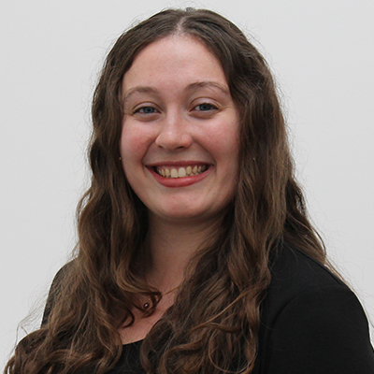 | My name is Haley Berrisford, and I am a student in the Master of Science in Health and Exercise Sciences program at the University of British Columbia Okanagan (UBCO). I am in the Spinal Cord Injury (SCI) Action Canada lab under the supervision of Dr. Kathleen Martin Ginis. My MSc thesis is centered on quality participation, happiness, and exercise maintenance among people with physical disabilities. I will start the PhD in Kinesiology program at UBCO remaining in the SCI Action Canada Lab in the Fall of 2025. I am looking forward to improving my knowledge of partnership research, building connections with those attending the CDPP 2.0 Summer Institute, and opening the door for future collaborations and partnerships.

Bob-Manuel, Tamunoemi (He/Him)
In-person attendee

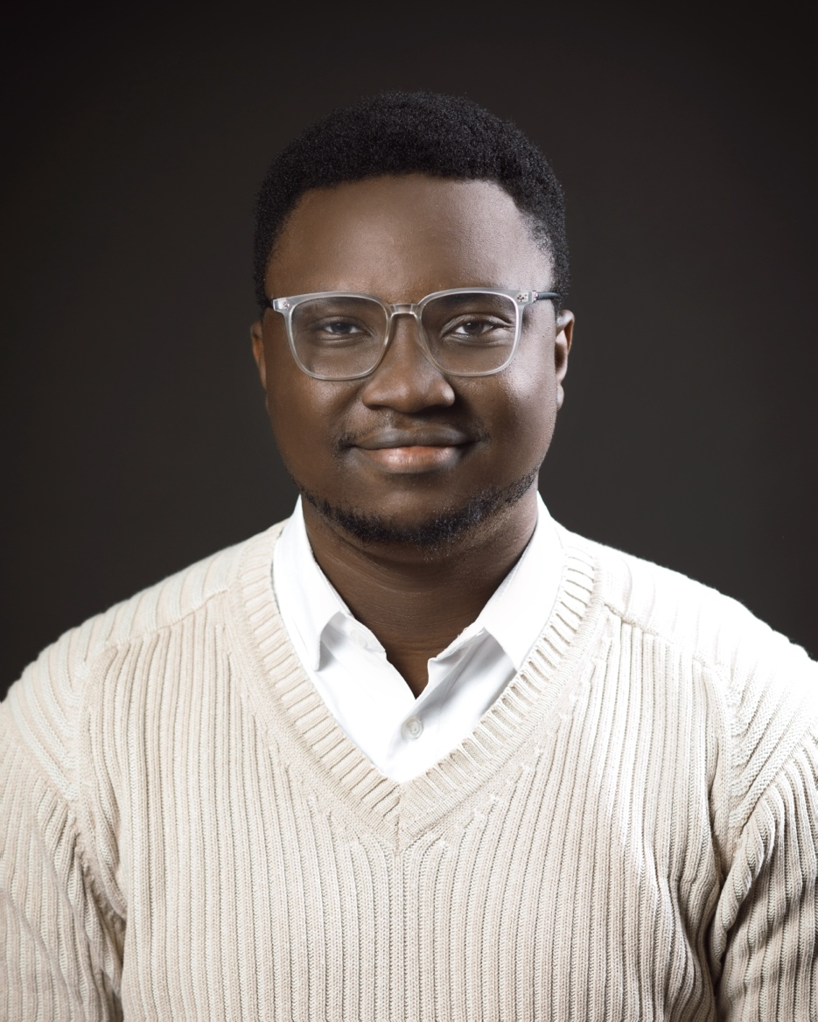 | My name is Tamunoemi Bob-Manuel, and I am a first-year graduate student in the MSc Rehabilitation Science program at the School of Rehabilitation Therapy, Queen’s University. My research focuses on fostering quality participation for youths and adults with intellectual and developmental disabilities (IDD) in community-based exercise programs, as well as facilitating training in quality participation for staff working with this population. My research is supervised by Dr. Afolasade Fakolade. Attending the CDPP 2.0 Summer Institute will allow me to engage with a network of researchers and community partners across Canada who share similar interests and goals. In addition, I aim to share insights and apply learnings from this summer institute to both my current and future work.

Capone, Alessia (She/Her)
In-person attendee

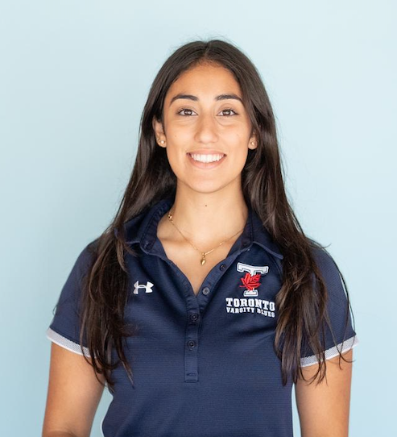 | My name is Alessia Capone, I am a second year PhD candidate at the University of Toronto in the faculty of Kinesiology and Physical Education. Working under the supervision of Dr. Kelly Arbour-Nicitopoulos I am involved heavily in the family engagement work that is being done at the CDPP. I am interested in highlighting the importance of engagement and relational research for improving accessibility and belonging of children with disabilities and with multiple minority identities. I am interested in attending the Summer Institute to continue to push research to be done in a good way, and how we may contribute to reconciliation with Canada's colonial past and present.

Disimino, Katerina (She/Her)
Online attendee

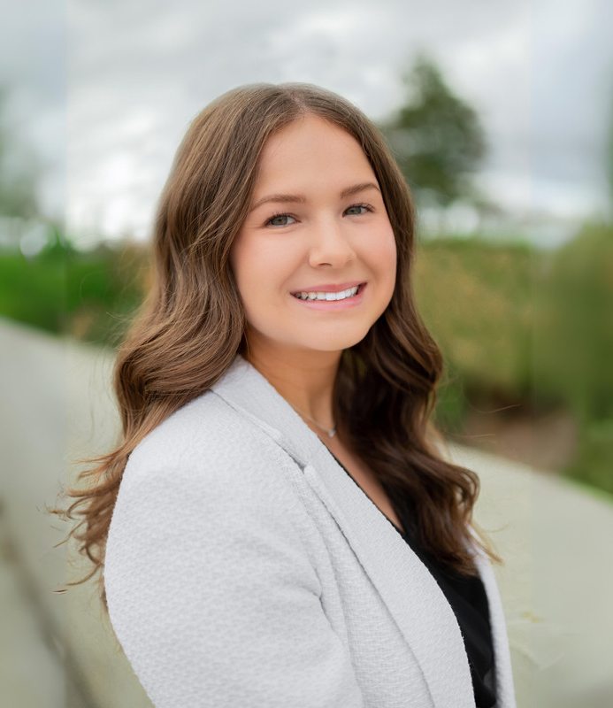 | My name is Katerina Disimino, and I am a PhD candidate in the School of Kinesiology and Health Science at York University under the supervision of Dr. Rebecca Bassett-Gunter. My research focuses on exploring strategies to disseminate and implement recommendations that will support community-based organizations in the development of targeted physical activity information for parents of children living with a disability. This knowledge mobilization initiative aims to bridge the research to practice gap and generate community-level impact through enhancing physical activity engagement among children living with a disability. I am attending the CDPP 2.0 Summer Institute to enhance my knowledge mobilization skills, learn more about effective partnership strategies, and build meaningful professional connections with other researchers.

Gee, Cameron (He/Him)
Online attendee

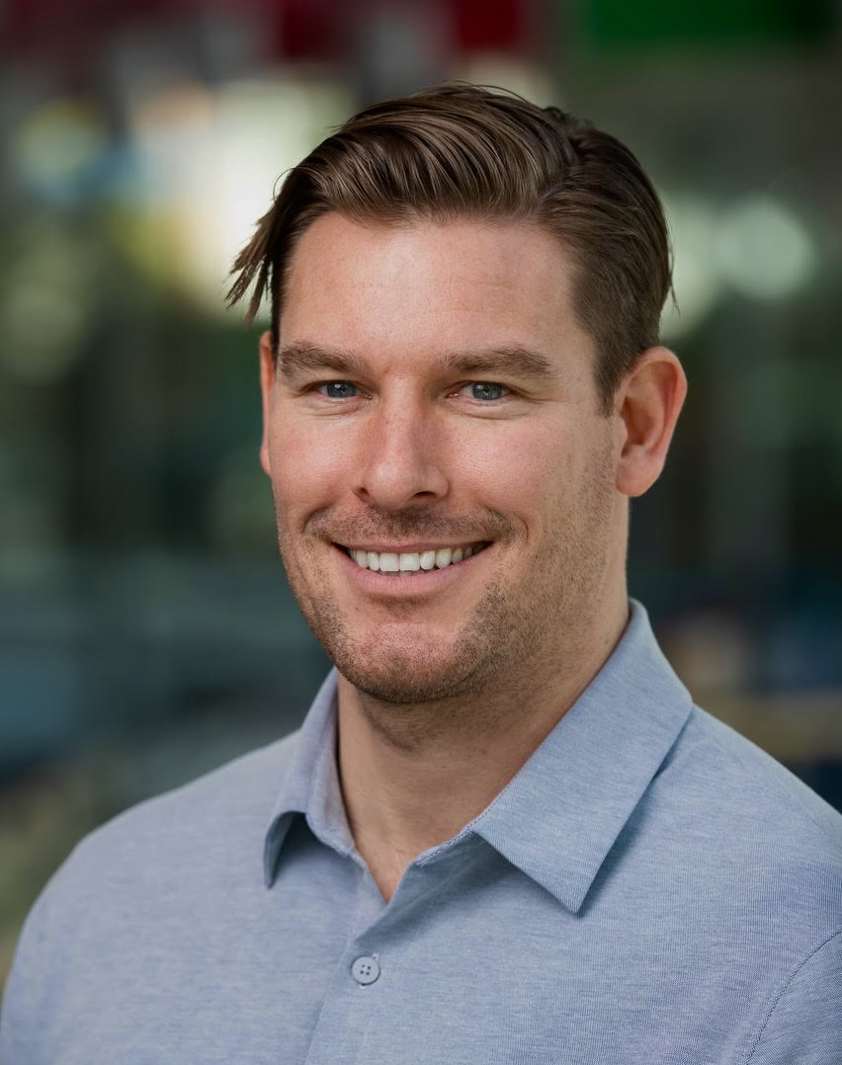 | Post-doctoral fellow studying exercise for people with spinal cord injury and other disabilities at UBC under the supervision of Dr. Kathleen Martin Ginis. I'm attending CDPP 2.0 to learn about the science and practice of quality participation and partnership in disability exercise research.

Grimes, Alyssa (She/Her)
In-person attendee
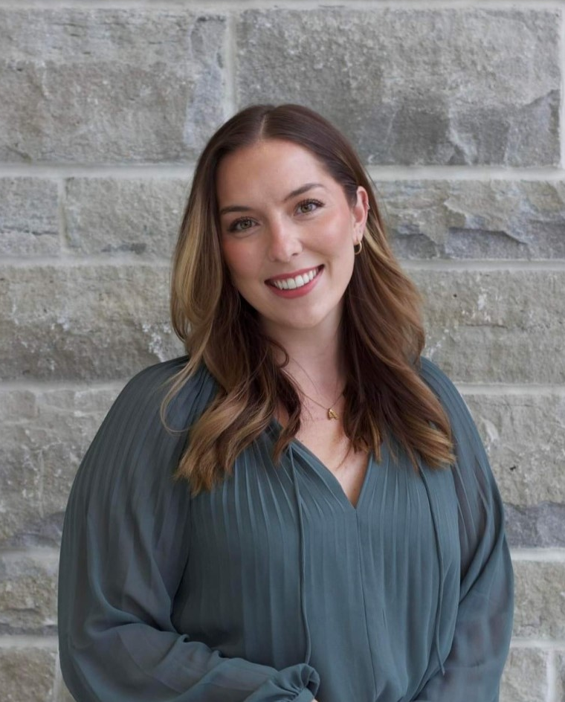 | Alyssa Grimes is a PhD candidate at Queen's University working under the co-supervision of Dr. Amy Latimer-Cheung and Dr. Carolyn Emery. Her doctoral research focuses on concussion prevention in Para sport. She is attending the inaugural CDPP 2.0 Summer Institute to deepen her understanding of research partnerships and strategies for enhancing quality sport programming for persons living with disability. She is excited to collaborate with peers and experts who share the same passion for enhancing inclusive sport experiences.

Juan, Owen (He/Him)
Online attendee
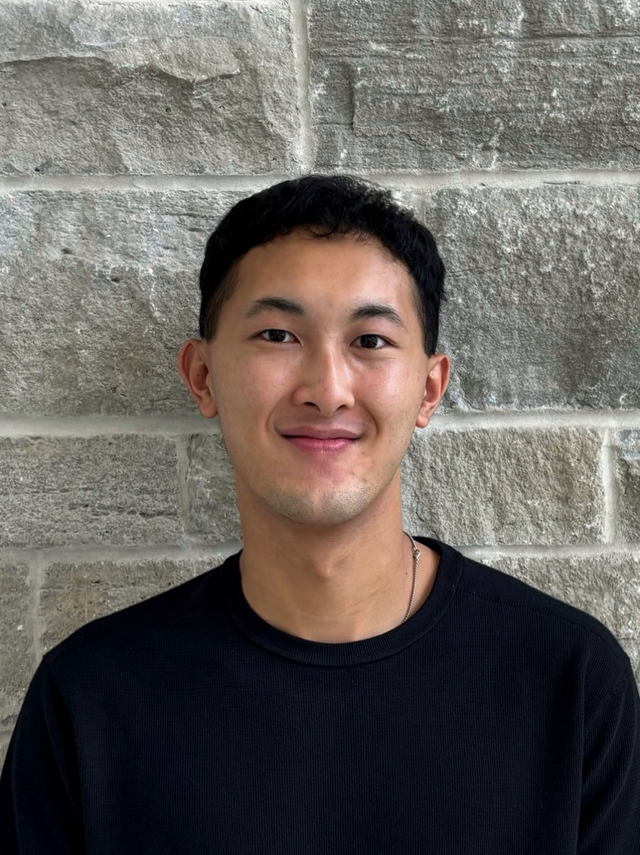 | My name is Owen Juan and I am an incoming MSc student at Queen's University under the supervision of Dr. Jennifer R. Tomasone. My research is focused on health promotion and intersectional considerations for persons experiencing disability. I am excited to attend the CDPP 2.0 Summer Institute to learn more about the field of disability studies and how to create meaningful partnerships in research.

Locke, Maggie (She/Her)
In-person attendee

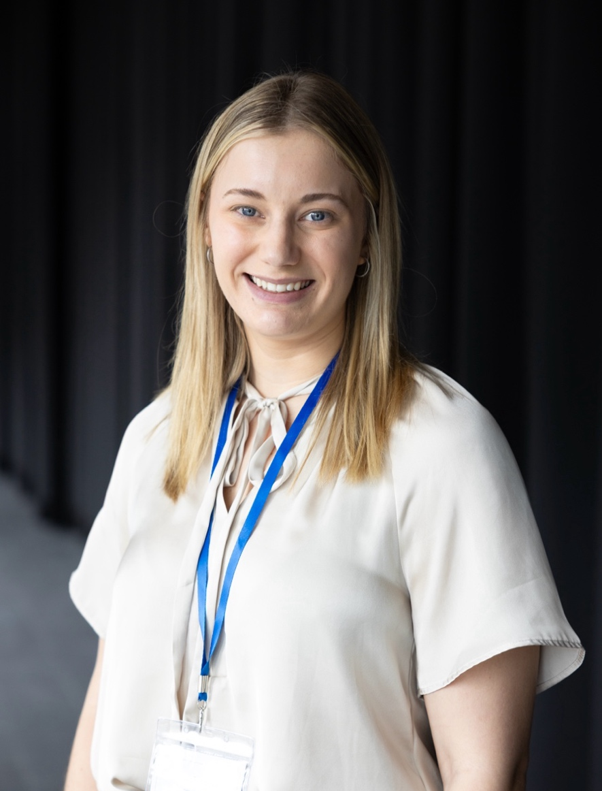 | My name is Maggie Locke, I am currently a PhD in Health student at Dalhousie University under the supervision of Dr. Sarah Moore, who is leading the risky play working group within the active play team. My role as the research coordinate for the risky play working group is to facilitate meetings with our diverse team of researchers and people with lived experience and to ensure that their unique perspectives and meaningful ideas are represented throughout the entirety of our projects. In attending the CDPP 2.0 Summer Institute I aim to gain further strategies to support and incorporate co-design within my research, while expanding my network of student researchers within the larger CDPP 2.0 community. This will facilitate future collaboration across working groups as we share the collective goal of mobilizing new knowledge to improve access and inclusion to quality participation among children and adults living with disabilities.

Mahmoudi, Ebrahim (He/Him)
Online attendee
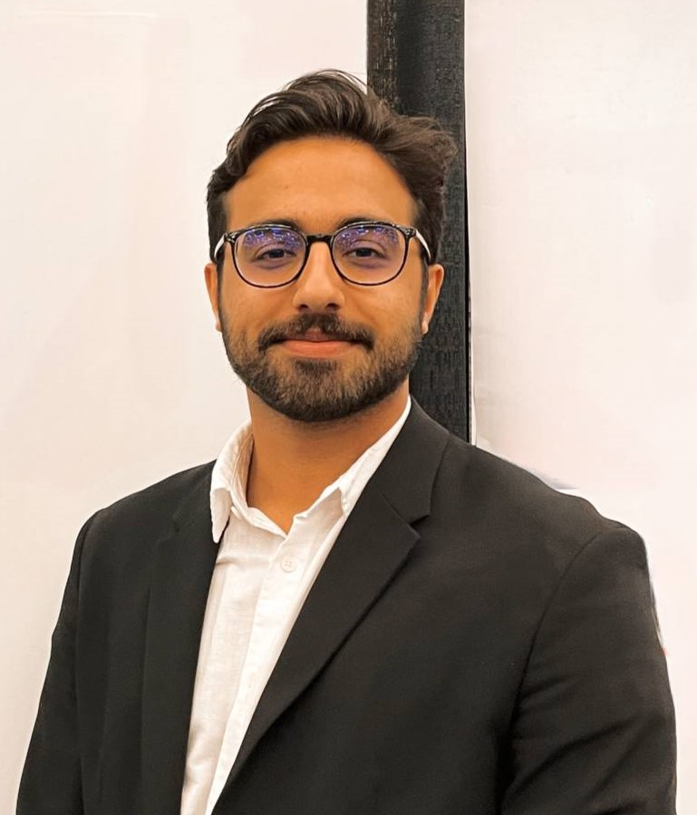 | Ebrahim Mahmoudi is a PhD candidate in Rehabilitation Science at McGill University and an occupational therapist by training. He is currently working under the supervision of Dr. Keiko Shikako to co-design and evaluate a gamified digital health technology, the Jooay App, in collaboration with youth with disabilities, parents, and clinicians. The goal is to promote participation in leisure activities among children and youth with disabilities.  During his PhD research, Ebrahim has witnessed the transformative power of partnerships with individuals with lived and living experience, as well as with other research collaborators. He hopes to further deepen his understanding of how to sustain meaningful research partnerships and to engage in critical reflection on this process.

Mullan, Marley (She/Her)
In-person attendee

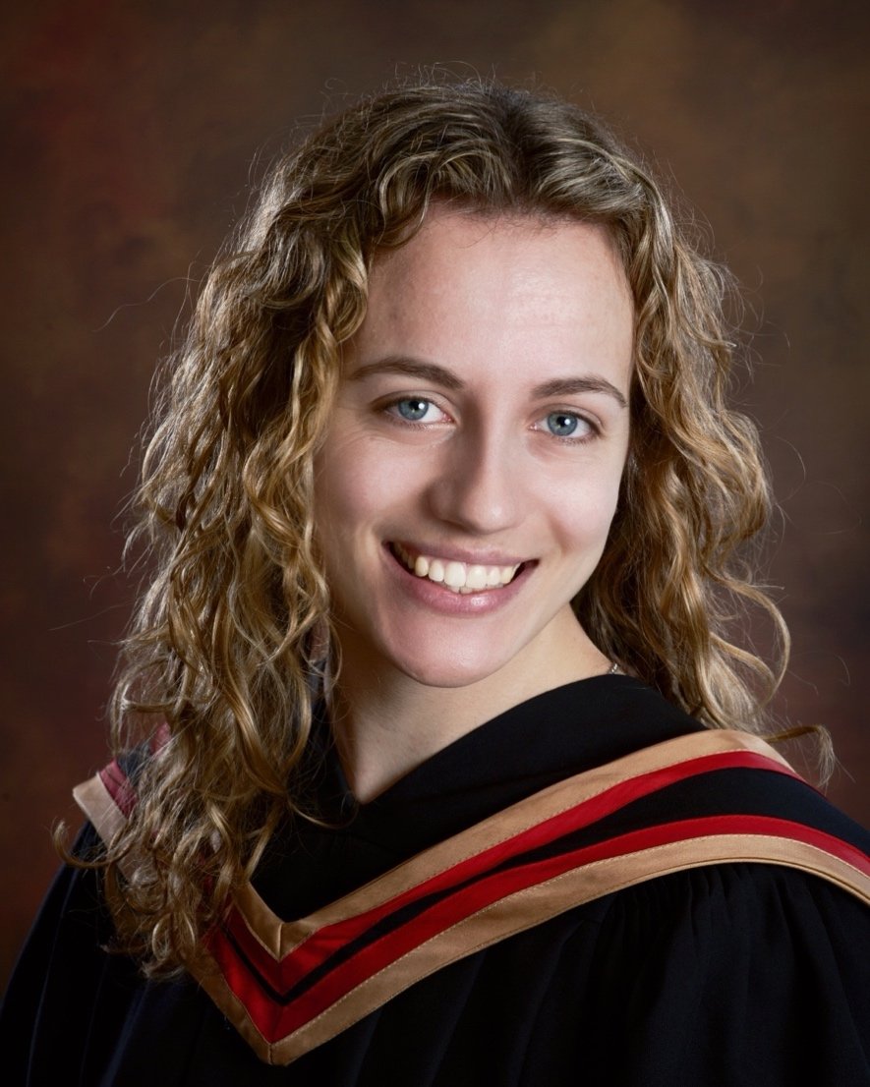 | Marley Mullan is a first-year PhD student in the School of Kinesiology and Health Studies at Queen’s University. She is a member of the Revved Up Research Group, studying under the supervision of Dr. Jennifer Tomasone. Her Master’s thesis work involved a secondary data analysis of Canadian Campus Wellbeing Survey data to better understand the movement behaviours of students experiencing disabilities among post-secondary campuses nationwide. She is also involved in a collaborative project between Queen’s University and McGill University, exploring the behaviour change techniques used by persons experiencing disabilities in physical activity settings. Marley is eager to attend the CDPP 2.0 Summer Institute to collaborate with peers in similar fields of study, learn from highly regarded disability researchers, and work as a team to plan upcoming disability research in Canada.

Naqvi, Zainab (She/Her)
In-person attendee

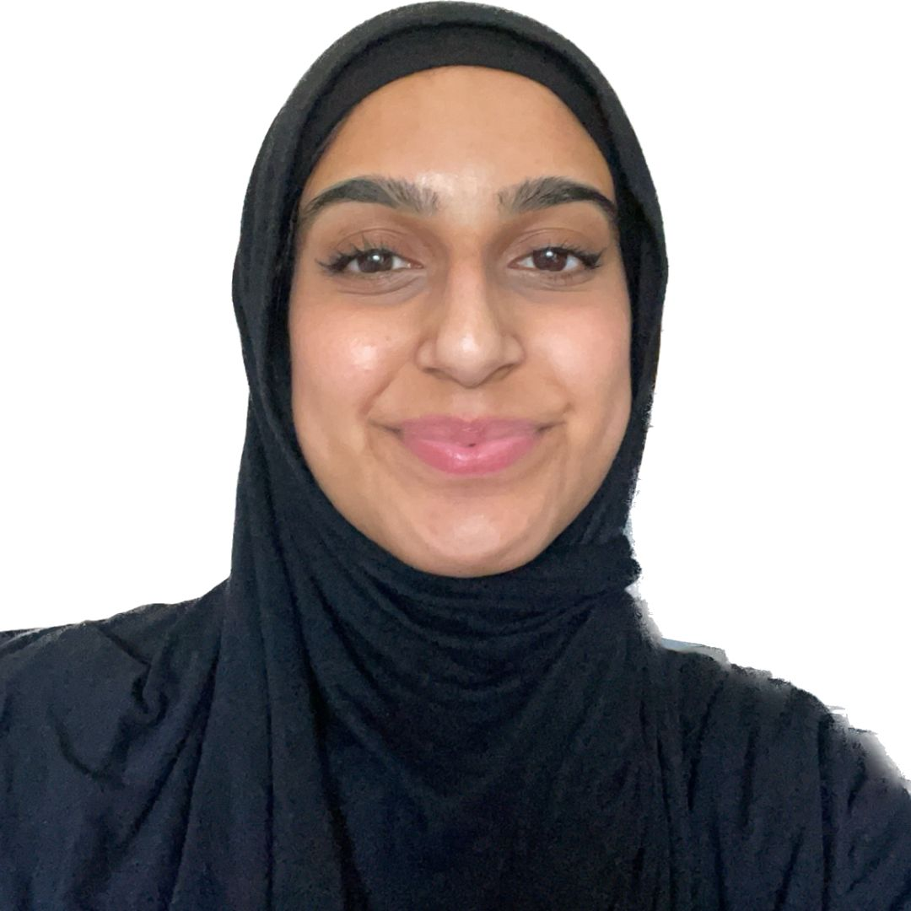 | Hello! My name is Zainab Naqvi, and I am a Master's Student at Queen's University in the School of Kinesiology and Health Studies, supervised by Dr. Amy Latimer-Cheung. I am always wanting to be a better scholar, recognizing that this requires working on-the-ground, immersing myself in literature, and chasing opportunities such as the CDPP 2.0 Summer Institute to meet like-minded peers and mentors that challenge my perspectives and biases, and encouraging me to keep learning. Meaningful relationships are essential, and this Summer Institute provides an awesome opportunity to meet, connect, and learn with others.

Neufeld, Jake (He/Him)
Online attendee

 | My name is Jake Neufeld, I am completing an M.Sc. in Health Sciences, through the College of Medicine at the University of Saskatchewan. My research area is in the field of clinical neurorehabilitation, specifically for individuals with multiple sclerosis (MS). I am grateful to get to work with my supervisors Dr. Sarah Donkers and Dr. Valerie Caron and for all that they have taught me over the last two years. I am excited to be part of the CDDP 2.0 Summer School to learn from researchers outside of my field and to be able to use this knowledge as inspiration for directing research projects in the future.

Noguchi, Kenneth (He/Him)
Online attendee

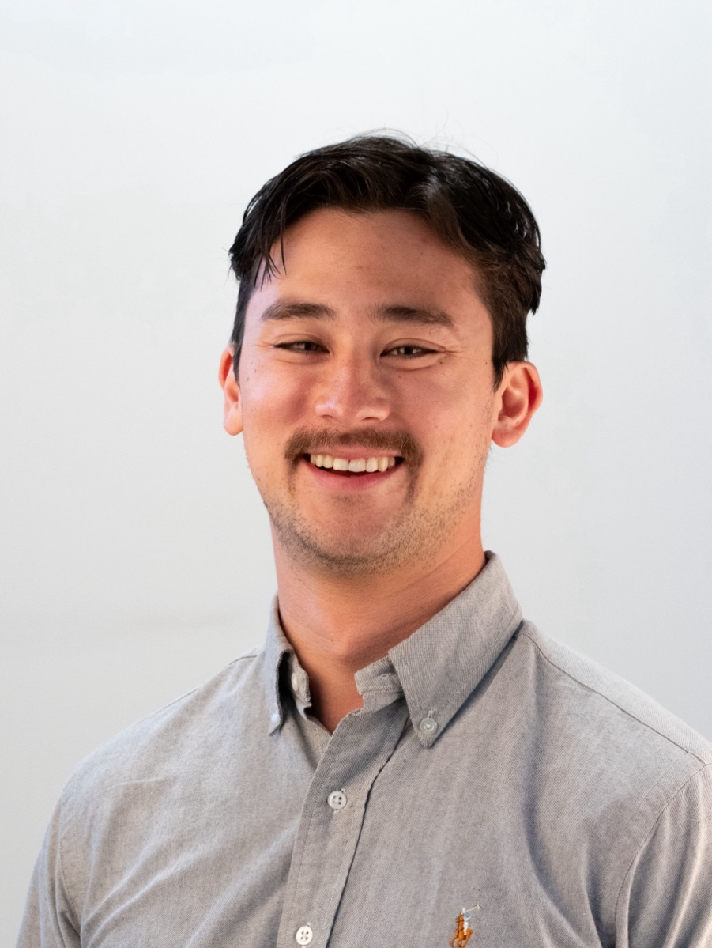 | I am a Postdoctoral Fellow at the University of British Columbia working with Dr. Kathleen Martin Ginis in the School of Health and Exercise Sciences. My PhD thesis was on the effects of strength training and factors associated with participation in individuals with stroke. With Dr. Martin Ginis, I am now exploring a new perspective to examining physical activity participation, using the Quality of Participation Framework. I am examining quality of participation profiles of people with disabilities that best predict physical activity participation and subjective wellbeing. Since I am new to this area of research, I am excited to attend the CDPP 2.0 Summer Institute to learn more about how the Quality of Participation Framework is being applied.

Purdy, Adam (He/Him)
In-person attendee
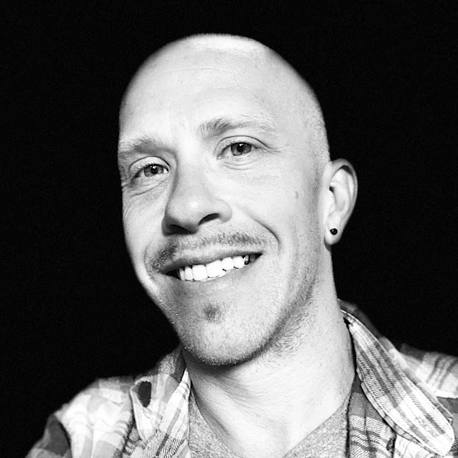 | My name is Adam Purdy and I am a second year PhD student at Western University, in the faculty of Health Sciences and School of Kinesiology. I am working under the supervision of Dr. Laura Misener. I am attending the CDPP 2.0 to connect with other researchers, build partnerships and help advance the ways in which disability impacts participation (and vice versa) in our society.

Rassi, Sepehr (He/Him)
Online attendee

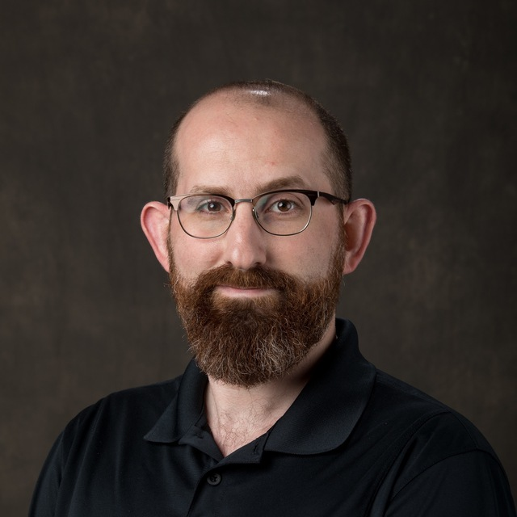 | My name is Sepehr Rassi, and I am a PhD candidate in the School of Kinesiology and Health Science at York University. My research focuses on developing inclusive physical activity programs for autistic children and youth. Under the supervision of Dr. Rebecca Bassett-Gunter, I am currently working on a community-based project that adapts a health-promotion exercise program to better support the needs of autistic children and youth. I am attending the CDPP 2.0 Summer Institute to connect with other trainees and researchers who are passionate about disability and inclusion, and to gain deeper insight into knowledge mobilization strategies that can enhance the reach and impact of my work. I look forward to learning from both mentors and peers and contributing to a growing network of scholars committed to improving participation opportunities for individuals with disabilities.

Silverman, Rayona (She/Her)
In-person attendee

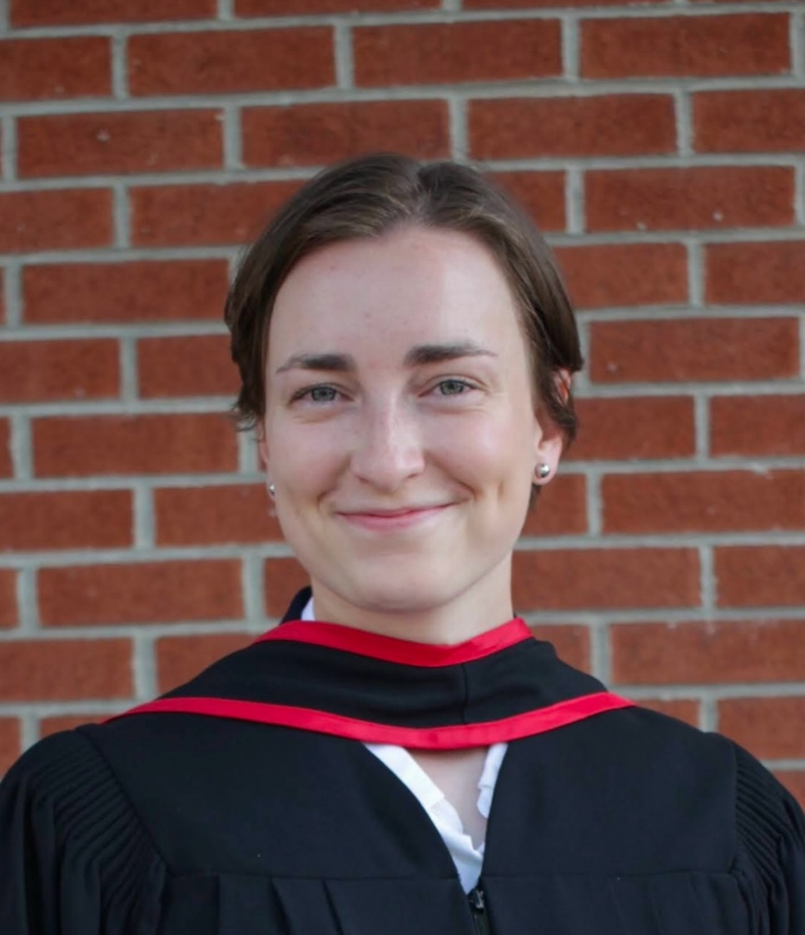 | Rayona Silverman is an incoming first year PhD student at Acadia University, studying under the supervision of Dr. Emily Bremer. Her PhD is focused on Inclusive Education, looking at quality participation in active play for children and youth with disabilities within the Canadian school system. Rayona is attending the CDPP 2.0 to engage in meaningful discussions, build connections and partnerships with fellow attendees, and learn more about how to apply partnership guiding principles to research and knowledge mobilization practices.

So, Sofia (She/Her)
Online attendee

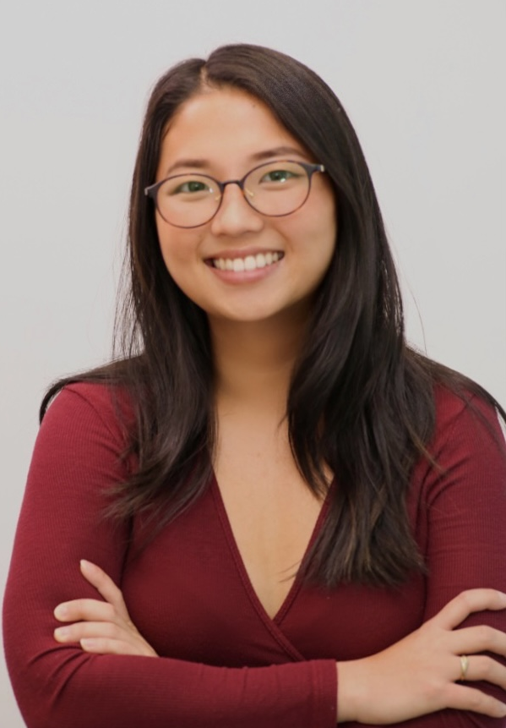 | My name is Sofia So, and I am a Master's student in Health Promotion at Dalhousie University. My research focuses on promoting inclusion and improving access to adapted sport and physical activity opportunities for children and youth with disabilities. I am supervised by Dr. Sarah Moore and am actively involved in Canadian Disability Participation Project (CDPP) 2.0 Sport initiatives focused on quality participation implementation.  I am attending the CDPP 2.0 Summer Institute to continue learning from others who are passionate about creating inclusive opportunities and to build connections with other researchers. I hope to gain insights, practical strategies, and tips from others' experiences that can help strengthen my work within the CDPP 2.0 Sport projects and in my broader research on inclusion and participation.

Szydlowski, Gabriela (She/Her)
Online attendee

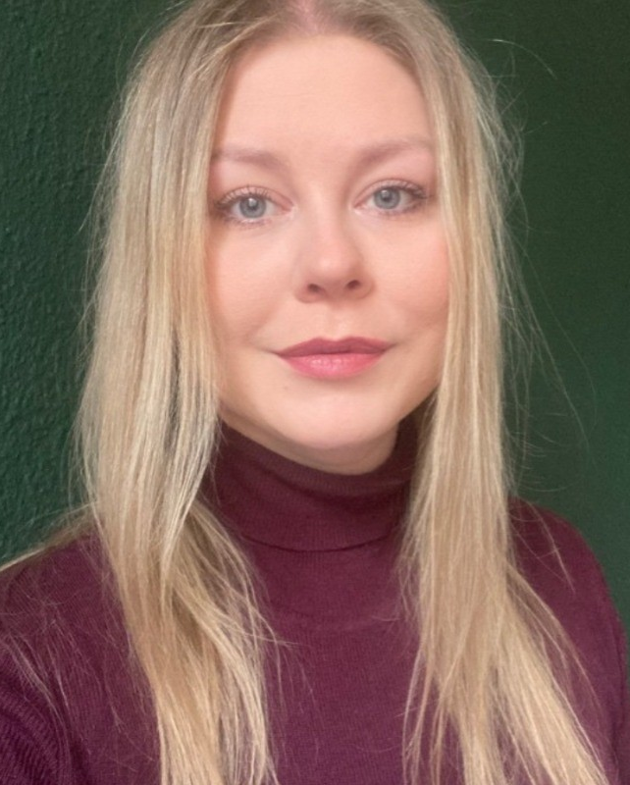 | My name is Gabriela Szydlowski and I am a postdoctoral researcher at McGill University, working under the supervision of Dr. Keiko Shikako. My research focuses on childhood disability, implementation science, knowledge translation, and public policy. With a background in behavioral public administration and an interest in bridging research and practice, I am passionate about improving health and social outcomes for children with disabilities and their families.  I am attending the CDPP 2.0 Summer Institute to deepen my understanding of the field of childhood disability research, which is new to me but deeply meaningful. I am especially looking forward to learning about inclusive and collaborative research practices, and to connecting with a community of scholars and practitioners who share a commitment to equity, accessibility, and social justice.

Tang, Kailan (She/Her)
Online attendee

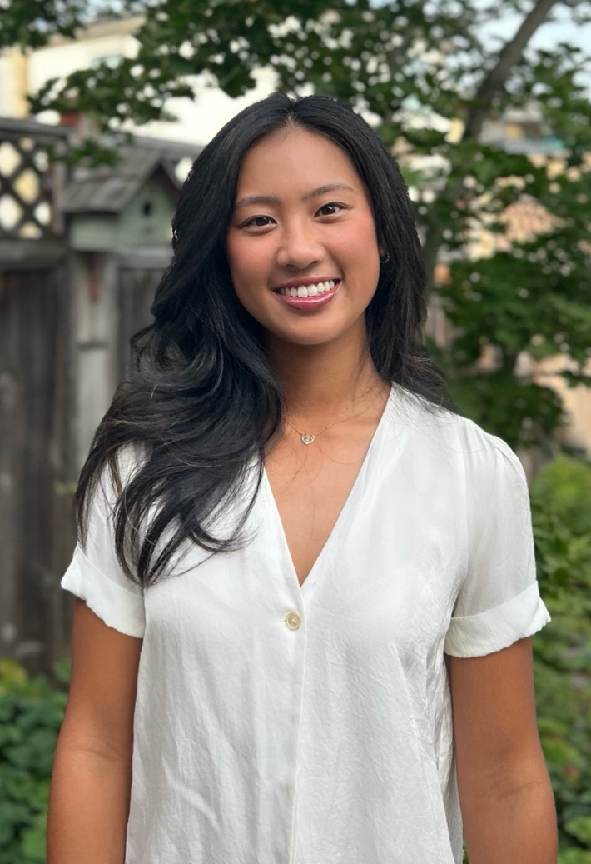 | My name is Kailan Tang, I am a second year Master of Arts in Kinesiology at the University of British Columbia. Under the supervision of Dr. Andrea Bundon, my master's thesis aims to understand youth with spinal cord injury and parents' experiences with seeking and navigating physical activity.  I am excited to attend the CDPP 2.0 Summer Institute to deepen my understanding of how to enhance quality physical activity experiences for people with disabilities—an area that closely aligns with my research interests. Committed to inclusion, equity, and community-engaged research, I’m drawn to the program’s focus on partnerships, evidence-based innovation, and meaningful impact. I look forward to learning from and collaborating with leaders across academia and the community, and gaining insights from diverse lived experiences of disability.

Taylor, Leah (She/Her)
In-person attendee

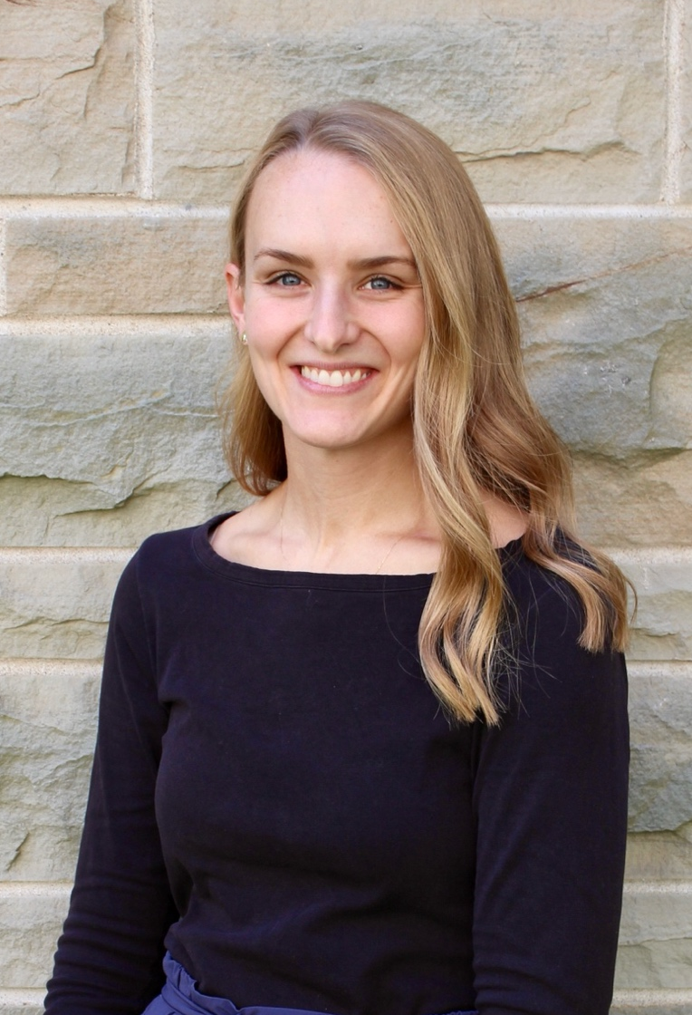 | My name is Leah Taylor, and I am a PhD Candidate and OT student at Western University, where I study paediatric occupational therapy with a focus on inclusive physical activity and the implementation of the Canadian 24-Hour Movement Guidelines for children with disabilities. Under the supervision of Dr. Trish Tucker, my research centres on knowledge translation and co-design strategies to support occupational therapists in promoting movement behaviours in early childhood. I am attending the CDPP 2.0 Summer Institute to deepen my understanding of collaborative research approaches that centre lived experience, expand my network of like-minded scholars, and strengthen my capacity to drive change in the field of paediatric rehabilitation.

Walters, Alexandra (She/Her)
In-person attendee
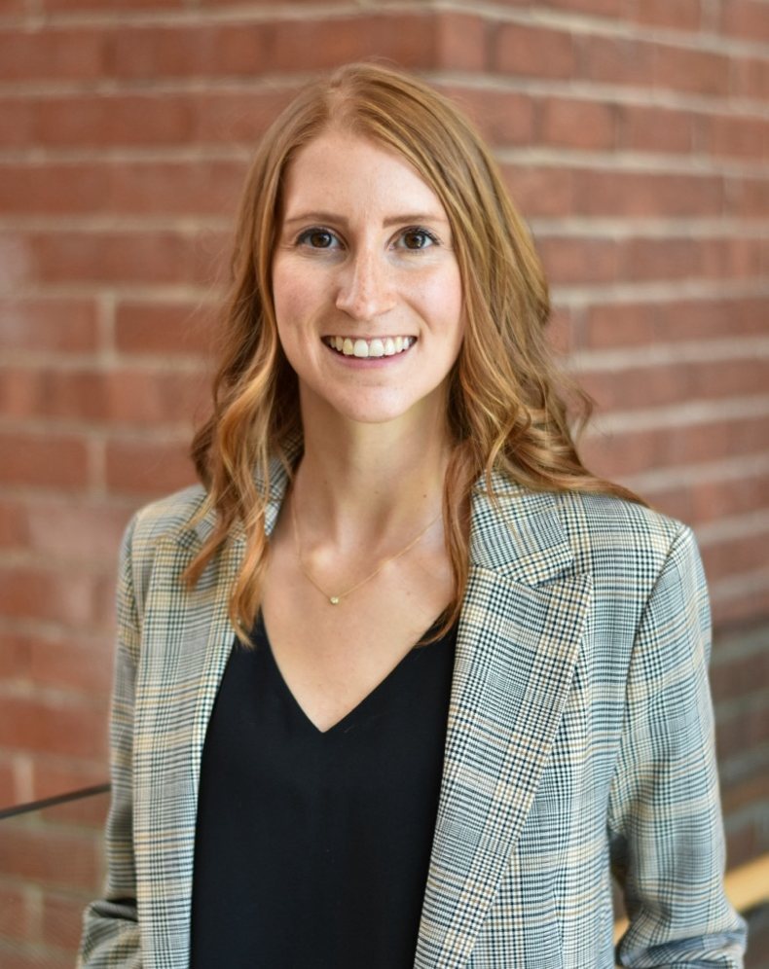 | I am a postdoctoral fellow in the School of Health and Exercise Sciences at the University of British Columbia Okanagan, supervised by Dr. Heather Gainforth. Broadly, my research focuses on physical activity for persons with disabilities, with an emphasis on research co-production and equitable research partnerships. I am currently co-developing partnership evaluation tools with disability-focused organizations. I also serve as the Knowledge Mobilization Manager for the CDPP 2.0. I'm attending the CDPP 2.0 Summer Institute to deepen my understanding of integrated knowledge translation, strengthen my network of trainee researchers and partners, and contribute to advancing inclusive research practices.

Wing, Meredith (She/They)
In-person attendee

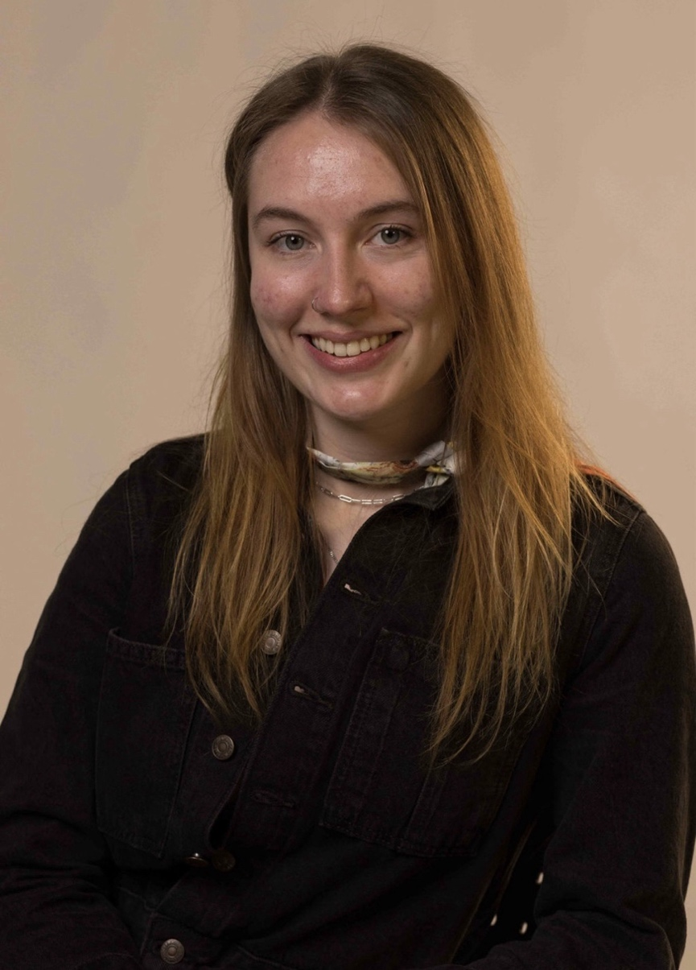 | My name is Meredith Wing, and I am a white queer scholar who experiences disability. I am grateful to be currently living and growing on the traditional lands of the Omamìwìnini Anishnàbeg (Algonquin) as an MA student at the University of Ottawa in the School of Human Kinetics. To continue following my curiosity and developing my passion for disability justice, I will transition into the PhD Human Kinetics program in the Fall of 2025, with the support and supervision of Dr. Andrea Bundon and Dr. Audrey Giles. As a participant in the CDPP Summer Institute, I look forward to sharing the space provided by the program with peers, forming meaningful connections, and learning together as we navigate our various academic journeys. In future, I hope to contribute further to this wonderful community of scholars working within the disability space and do my part to cultivate a culture of care.

Abstracts

Albert, Ueli (He/Him)
Online attendee

Abstract Title: How coaches can foster quality sport experiences for adult para-athletes living in Nova Scotia

Abstract Authors and Affiliations:
Albert, U.¹, & Bremer, E.²
¹School of Education, Acadia University, Wolfville
²School of Kinesiology, Acadia University, Wolfville

This study examines the quality of sport experiences among adult para-athletes in Nova Scotia, with a particular focus on the role of coaches in fostering quality participation. Using a cross-sectional mixed-method design, the research applies a social-relational lens to investigate the experiential aspects of participation. In this ongoing study, participants (target N = 40) complete an online survey measuring demographic characteristics, the Measurement of Experiential Aspects of Participation (MeEAP), and open-ended questions about coaching strategies to foster quality participation.

Data collection will be complete by March 2025 and full results will be presented at the conference. As of abstract submission, 10 participants (M age = 37, 30% female) have completed the survey. Preliminary quantitative analyses revealed an average MeEAP score of 5.9 (out of 7), with mean scores for each dimension as follows: autonomy (6.0), belonging (6.4), challenge (5.6), engagement (5.7), mastery (5.8), and meaning (6.0). The highest scores reflected participants' strong sense of belonging, while the lowest scores highlighted challenges in feeling appropriately challenged. Independent t-tests and correlations will explore differences in quality experiences based on demographic and sport-specific factors, such as years of participation and level of competition (local, provincial, national, international).

Qualitative thematic analysis of the open-ended responses will provide deeper insights into key factors influencing quality participation. So far, participants have emphasized the critical roles of coach behaviors—such as effective communication and tailored adaptations—as well as organizational structures, including opportunities for inclusive practices and accessible competition formats. The interplay of these factors was seen as instrumental in creating environments that promote meaningful and engaging sport experiences for para-athletes.
We anticipate that this study will underscore the importance of individualized coaching strategies and systemic adaptations to enhance engagement, satisfaction, and long-term participation in parasport. The discussion will offer actionable recommendations for coaches and program leaders, contributing to the broader literature on adaptive sports. This research also serves as the foundation for the development of evidence-based workshops designed to improve the quality of parasport programs in Nova Scotia.

Berrisford, Haley (She/Her)
In-person attendee

Abstract Title: Is Quality Participation in Exercise Related to Happiness and Long-Term Behaviour Maintenance Among People with Disabilities

Abstract Authors and Affiliations:
Berrisford, H. A.¹, & Martin Ginis, K. A.¹⁻²
¹School of Health and Exercise Sciences, University of British Columbia Okanagan
²Department of Medicine, University of British Columbia Okanagan

Quality participation (QP) in exercise for people with disabilities, satisfies personal values and needs for autonomy, belongingness, challenge, engagement, mastery, and meaning (Evans et al., 2018). The QP framework was designed to operate under optimal experience theories and prevalent psychological theories to enhance its applicability (Evans et al., 2018). Drawing on Self-Determination Theory (Deci & Ryan, 1985), PERMA Theory of Well-Being (Seligman, 2011, 2018) and Social Cognitive Theory (Bandura, 1982, 1997) quality exercise participation experiences should be linked to better subjective well-being and exercise maintenance. However, minimal research has explored these relationships. We aim to measure QP in exercise over time to determine if repeated quality experiences lead to changes in happiness and to explore the relationship between QP and continued exercise participation among people with disabilities.
Participants (n=15) are adults with physical disabilities enrolled in a 24-session exercise program with two sessions per week of aerobic and strength training. After each session, participants rate QP using the Measure of Experiential Aspects of Participation (Caron et al., 2019) and happiness using the Subjective Happiness Scale (Lyubomirsky & Lepper, 1999). Participants can re-enroll in the program. Individualized summary reports will be created for each participant to inform semi-structured interviews about their reasons for re-enrolling in the program and how their session-by-session QP and happiness scores resonate with their overall program experiences. Narrative analysis will be undertaken to understand decisions to re-enroll in the exercise program. N-of-1 analysis will be conducted to test the relationship between QP elements and happiness over time.
This study builds on the theoretical considerations of the QP framework and uses N-of-1 methods to capture the full variability of participant experiences and test theory-driven hypotheses. This study will help inform researchers and practitioners on the value of QP in exercise.

Bob-Manuel, Tamunoemi (He/Him)
In-person attendee

Abstract Title: Enhancing inclusive community-based exercise programs for adolescents & adults with intellectual and developmental disability using education modules.

Abstract Authors and Affiliations:
Bob-Manuel, T.¹, Fakolade, A.¹, & Bobbette, N.¹
¹Queen’s University, Canada

In Canada, participating in community-based exercise programs is essential for the well-being of adolescents and adults with intellectual and developmental disabilities (IDD). However, coaches and volunteers lack the necessary social curriculum and resources to engage with persons with IDD due to a lack of training. This thesis addresses the need for effective educational frameworks and modules specifically designed for coaches, and volunteers in various community centers across Canada working with adolescents and adults with IDD to enhance quality participation.
This study will employ qualitative research methods, particularly in-depth interviews with coaches and volunteers, to understand their experiences, challenges, and perceptions regarding their roles in inclusive exercise programs in enhancing quality participation for adolescents and adults with IDD. Understanding the barriers they face and the factors that motivate them will help identify the specific knowledge gaps and training needs necessary for effective engagement. Results from these interviews will inform the design of educational modules that facilitate interactive community-based exercise programs.

In addition, this thesis will focus on identifying the supports and resources that would empower coaches and volunteers to utilize the educational modules developed. This research will not only address this gap but also contribute to the promotion of inclusive exercise programs across communities. The designed module will incorporate diverse representation from Canada across various communities such as Special Olympics Canada, Adaptive, Resistance Intensive Personal Training (RIPT), Abilities Center, and Smile Canada-Support Services to ensure inclusivity across age, gender, language, and type of disability. By building scenarios and teaching cases, the module aims to enhance the knowledge and understanding of staff and volunteers in delivering quality programming that promotes quality participation for adolescents and adults with IDD.

The findings will help bridge current training gaps and create a model for quality participation training in other community settings. The project's broader impact includes promoting equitable, inclusive practices and expanding partnerships with community organizations. This thesis aligns with the CDPP 2.0 mission by combining innovative research with practical applications to create a sustainable, inclusive framework for community-based exercise programming for adolescents and adults with IDD.

Capone, Alessia (She/Her)
In-person attendee

Abstract Title: Partners in Progress: Outputs and Mechanisms for Collaborating with Caregivers and Researchers in Disability Research.

Abstract Authors and Affiliations:
Capone, A. M.^{1,2}, Arbour-Nicitopoulos, K.^{1,2}, & The CDPP FER Team²
¹University of Toronto, Faculty of Kinesiology and Physical Education
²Canadian Disability Participation Project 2.0

Background: Family Engagement Research (FER) is a common approach used in healthcare to enhance the relevance and reach of research for families of children with disabilities. The CDPP FER team, established in 2023, aims to build authentic, quality engagement opportunities in physical activity research for children with disabilities. This team includes caregivers of children with disabilities, disability researchers, and trainees. Collectively, the FER team works together to support the relevance, applicability, and innovation of CDPP research initiatives.

Aim: This thesis talk will describe the mechanisms and outputs of the FER Team and some of the initial lessons learned.

Findings: The FER team employs a multi-method approach to team communication, decision-making, partner compensation, and feedback. Several outputs and processes have been created by the FER Team to uphold the iKT principles of the CDPP. These outputs include: terms of reference, partner compensation guidelines, an involvement matrix, monthly meetings and supplemental ‘coffee’ chats, meeting minutes, team surveys, a monthly FER Team newsletter, and verbal discussions (group-based and 1:1). A notable mechanism is the project matching process, a three-stage approach ensuring transparency between researchers and caregiver partners, which allows caregivers to discuss project applicability and expectations with the FER coordinator. Key lessons learned include the importance of flexibility in processes and plans. Decision-making can be challenging particularly when trying to include all team members’ voices; thus, creating adaptable and iterative processes can help to ensure group practices remain relevant and applicable. Another key lesson is that engagement research is driven by passion and not profession. Tasks like reviewing lengthy documents and drafting papers may not always be priorities for caregivers but can offer valuable experiences for those interested.

Conclusion: Successful engagement requires clear group expectations, with transparent and flexible processes that accommodate individual needs. Imposing uniform expectations on all members is inconsiderate and counterproductive. It is important that processes and outcomes remain cohesive and supportive of engagement that can be individualized. By prioritizing adaptability and inclusivity, the FER team enhances the impact and relevance of its research initiatives.

Disimino, Katerina (She/Her)
Online attendee

Abstract Title: Engaging Community-Based Organizations in Dissemination and Implementation to Foster Quality Physical Activity Promotion for Children and Youth Living with a Disability

Abstract Authors and Affiliations:
Disimino, K.¹, & Bassett-Gunter, R. L.¹
¹School of Kinesiology and Health Science, York University

Innovative physical activity (PA) promotion strategies are needed to enhance quality PA participation among children and youth living with a disability (CYLD). Community-based organizations (CBOs) that offer PA programs for CYLD are ideally situated to promote quality PA, but often lack the knowledge required to engage in evidence-based PA promotion approaches. Researchers can provide academic and community partners with KMb training to build their capacity to engage in the KMb of research. Further, motivating parental support for PA is an evidence-based approach that CBOs can take to promote PA among CYLD. Five evidence-based recommendations have been created to guide CBOs in the development of inclusive PA information to promote parental support for PA. Strategies for disseminating and implementing the recommendations within CBOs are required to promote their widespread use. Micro-grant programs that award CBOs funding may be effective for facilitating CBO-led dissemination and implementation of the recommendations. This project will be guided by the Health Promotion Research Center dissemination framework and the Reach, Effectiveness, Adoption, Implementation, and Maintenance (RE-AIM) framework. With an overarching goal to foster quality PA promotion for CYLD, this dissertation seeks to: 1) understand self-efficacy levels and training needs of academic partners and CBOs in relation to supporting the KMb of research, and 2) evaluate micro-grant programs to facilitate CBO-led dissemination and implementation of a knowledge product. In Phase One, academic and community partners will complete a cross-sectional online questionnaire measuring self-efficacy levels and KMb training needs. In Phase Two, representatives from CBOs that offer PA programs for CYLD will participate in a micro-grant program to disseminate or implement the recommendations in their organization. A longitudinal case study design will be employed over a six-month period. Participants will complete questionnaires, interviews, and reports measuring CBO context and RE-AIM domains. Descriptive statistics and frequencies will be calculated for quantitative data, and thematic analyses will be performed for qualitative data. Findings will: 1) inform KMb training opportunities for academic partners and CBOs, 2) identify effective strategies for facilitating CBO-led dissemination and implementation, and 3) inform future micro-grant programs to facilitate CBO-led dissemination and implementation.

Gee, Cameron (He/Him)
Online attendee

Abstract Title: Exploring features of the parasport environment associated with quality participation

Abstract Authors and Affiliations:
Gee, C. M.¹, Evans, M. B.², Sinden, A. R.³, Shirazipour, C. H.⁴, Martin Ginis, K.⁵, & Latimer-Cheung, A. E.⁶

¹International Collaboration on Repair Discoveries (ICORD), University of British Columbia
²Department of Psychology, Western University
³School of Health and Exercise Sciences, University of British Columbia Okanagan
⁴Department of Medicine, UCLA
⁵Department of Medicine, University of British Columbia Okanagan
⁶School of Kinesiology and Health Studies, Queen’s University

The Quality Parasport Participation Framework (QPPF) proposes that features of the physical, program, and social environments (i.e., foundational strategies) foster quality participation which in turn support positive psychosocial outcomes. The link between foundational strategies and quality participation has not been empirically assessed. We examined whether features of the physical, program, and social environments predict quality participation and the strength of relationships between specific QPFF foundational strategies and quality participation. Participants were Canadian adults living with physical impairment/s (n=270, 44±14 years; 62% male), involved in 44 different parasports. Participants completed questionnaire measures of the extent to which they experienced 16 foundational strategies (corresponding to features within the physical, program, and social environments) and quality parasport participation. Separate forced entry hierarchical multiple regression models were computed for each environment. After controlling for covariates, the physical, program, and social environment models explained 18.4%, 22.3%, and 33.3% of the variance in quality participation, respectively (ps<.001). Quality participation was positively associated with access to sports equipment (β=.383), program affordability (β=.313), the number of levels of competition in which one participates (β=.199), training with peers of similar age (β=.182), friendship quality (β=.140), and feelings of safety during sport participation (β=.331; ps≤.010). Participation in higher levels of sport was negatively associated with quality participation (β=-.246, p=.004). Consistent with the QPPF, features of the physical, program, and social parasport environments predicted significant variance in quality participation. This study provides empirical support for the QPPF and a basis for directing program leaders to use QPPF strategies to foster quality participation in parasport.

Grimes, Alyssa (She/Her)
In-person attendee

Abstract Title: Building Inclusive Communities: Challenges in Advancing Disability Inclusion in Municipal Recreation Across Canada

Abstract Authors and Affiliations:
Grimes, A. C.¹, Barry, T.^{2,3}, & Latimer-Cheung, A. E.¹
¹ School of Kinesiology and Health Studies, Queen’s University, Kingston, Ontario, Canada
² Faculty of Kinesiology, Sport and Recreation, University of Alberta, Edmonton, Alberta, Canada

Background: Access to structured and unstructured recreational opportunities offer numerous physical, mental, and social benefits. Yet, people with disabilities have significantly fewer opportunities than other Canadians to enjoy the benefits of active recreation opportunities due to physical, social, and psychological barriers. Local governments (i.e., municipalities) play a crucial role in creating accessible environments and opportunities for physical activity. This study aimed to explore the current state of recreational opportunities for persons with disabilities across Canada and identify strategies municipalities can adopt to enhance disability inclusion. Methods: Data were generated from focus groups with adults with disabilities (n = 5), caregivers (n = 5), and municipal recreational staff (n = 10). Thematic analysis was used to identify key challenges, strategies, and solutions related to disability inclusion in municipal recreation. Results: Three themes were identified: (1) red tape and resistance to change, (2) advocacy and self-driven solutions, and (3) strengthening municipal capacity for disability inclusion. Participants identified siloed approaches to diversity, inadequate funding, and inconsistent application of inclusive policies as significant barriers. Success was linked to community partnerships, active leadership engagement, and the creation of specialized accessibility roles within municipal structures. Conclusion: The perspectives gathered in this study are relevant to the many knowledge users involved in the design and implementation of effective programming and policies to promote participation in recreation for children and adults with disability. These findings underscore the importance of maintaining disability inclusion as a municipal priority to ensure all individuals can fully participate in community life.

Juan, Owen (He/Him)
Online attendee

Abstract Title: Strategies for Implementing an Intersectional Lens in Disability Physical Activity Research and/or Knowledge Mobilization: A Scoping Review

Abstract Authors and Affiliations:
Juan, O.¹, Price, J.¹, Lim, H.¹, Chittenden, M.³, Lee, E-Y.¹, Sukhai, M.², Peers, D.⁴, & Tomasone, J. R.¹
¹School of Kinesiology and Health Studies, Queen’s University, Kingston, ON, Canada
²Department of Ophthalmology, School of Medicine, Queen’s University, Kingston, ON, Canada
³Library Accessibility Services, Queen’s University, Kingston, ON, Canada
⁴Faculty of Kinesiology, Sport, and Recreation, University of Alberta, Edmonton, AB, Canada

Persons experiencing disability often experience poor psychosocial outcomes due to individual factors in combination with broader environmental/societal forces¹. Participating in physical activity can help to minimize the risk of poor psychosocial outcomes and maintain overall health and functioning^{1,2}. However, persons experiencing disability are less likely to participate in physical activity as studies have indicated that individuals with marginalized social identities (such as disability, gender, low income) have lower physical activity participation rates³.

Intersectionality, the investigation of multiple overlapping social identities⁴, could be a useful tool or concept for understanding how persons with multiple overlapping social identities participate in physical activity⁵. As persons experiencing disability may also identify with other marginalized social identities (i.e., disability, race, low-income), an intersectional lens could prove especially useful in understanding how persons experiencing disability participate in physical activity. There have been many calls to utilize an intersectional lens within physical activity research^{5,6,7,8,9} and in disability research¹⁰, yet there is little guidance on how exactly researchers can implement an intersectional lens in either field of study. Indeed, a training needs survey of CDPP 2.0 members (academics, community partners, and trainees) in June 2024 identified intersectionality as a key area where capacity is needed.

Through a scoping review, we aim to compile a comprehensive list of strategies that can be used to implement an intersectional lens within disability physical activity research and/or knowledge mobilization. Furthermore, challenges related to the implementation of an intersectional lens will also be documented to help guide future training efforts or research. This scoping review will be guided by the Joanna Brigs Institute methodological framework¹¹ and will follow the Preferred Reporting Items for Systematic Reviews and Meta-Analyses Extension for Scoping Reviews (PRISMA-ScR)¹² for reporting.

The findings of this research will help to fill a gap in the literature by providing guidance for researchers on how an intersectional lens can be implemented in disability physical activity research and/or knowledge mobilization. Furthermore, this research will also help to support capacity-building within CDPP 2.0 as it pertains to implementing an intersectional lens in future research and/or knowledge mobilization efforts.

Locke, Maggie (She/Her)
In-person attendee

Abstract Title: The Lived Experiences of Children with Disabilities Participation in Risky Play

Abstract Authors and Affiliations:
Locke, M.^{1,2}, Allison, A.³, Best, K.⁴, Sora, D.⁵, & Moore, S. A.^{1,2,6,7}
¹School of Health and Human Performance, Faculty of Health, Dalhousie University, Halifax, Nova Scotia, Canada
²Healthy Populations Institute, Dalhousie University, Halifax, Nova Scotia, Canada
³Variety Village, Scarborough, Canada
⁴School of Rehabilitation Sciences, Faculty of Medicine, Université Laval, Quebec City, Canada
⁵Centre for Accessible Sport and Play, Ontario Parasport Collective of Toronto, Toronto, ON, Canada
⁶Department of Pediatrics, Faculty of Medicine, Dalhousie University, Halifax, Nova Scotia, Canada
⁷Pediatric Rehabilitation, IWK Health, Halifax, Nova Scotia, Canada

Background: Play is a fundamental component of childhood as it supports children’s physical and psychosocial health. Risky play, a form of play that is thrilling and exciting, which involves uncertainty and unpredictability, has unique benefits, as it provides children with opportunities to test their physical limits, develop their perceptual motor capacity, gain confidence, and learn risk management strategies. Unfortunately, children with disabilities (CWD’) have decreased opportunities to participate in risky play as they face additional barriers to play, such as inaccessible play spaces and increased risk-adversity, limiting their risky play opportunities. By understanding CWD’ risky play experiences through their own perspectives we can better support CWD’ risky play participation and their rights to play. Purpose: Therefore, the purpose of this research is to understand how CWD perceive risky play, how CWD define risky play, and the factors that impact CWD’ risky play participation. Methods: This study will include children with physical, neurodevelopmental, visual, and hearing related disabilities, between the ages of 7-14 years and who currently reside in Canada. We will recruit 12 children from each cohort for a total of 48 participants. Using a constructivist lens, this qualitative study will provide children with the opportunity to choose from three variations of interviews: (1) a semi-structure interview using an interview guide, (2) a storytelling, vignette style interview using an adapted script, or (3) a photo elicitation interview using an interview guide and photos that represent CWD’ risky play experiences. Interviews will be transcribed verbatim and analyzed using reflexive thematic analysis to identify and describe patterns and themes from the data. Photos from the photo elicitation interviews will be analyzed using interpretative thematic analysis. Significance: Findings from this study, will contribute to the Canadian

Disability Participation Project, which aims to co-create and mobilize new knowledge and interventions to improve the quality of participation for CWD’. Our previous research explored risky play from the perspective of the caregiver; through now understanding the perspective of the child we can develop interventions targeted at supporting caregivers and CWD’ to increase their access and quality participation within risky play.

Mahmoudi, Ebrahim (He/Him)
Online attendee

Abstract Title: Development of a Gamified Leisure Activity Mobile Application for Children and Youth With Disabilities: A Human-centered Design Approach

Abstract Authors and Affiliations:
Mahmoudi, E. ^{1,2,3}, Mehrnoosh Movahed ^{1,2,3}, Carlos Denner ⁴, Annette Majnemer ^{1,2,3}, Keiko Shikako ^{1,2,3}, and Jooay Research Team
¹School of Physical and Occupational Therapy, McGill University
²Centre for Interdisciplinary Research in Rehabilitation of Greater Montreal, Lethbridge-Layton-Mackay Rehab Centre
³Research Institute of the McGill University Health Centre
⁴Département de systèmes d'information et méthodes quantitatives de l’École de gestion de l’Université de Sherbrooke

Children and youth with disabilities participate less in leisure activities than their peers without disabilities. To address this gap, the Jooay mobile app, launched in 2015 by McGill University researchers, helps youth with disabilities and their families find adaptive and inclusive leisure activities in Canada. To enhance user engagement, we propose a gamified version of the app, leveraging mobile-based gamification to promote healthier behaviors and increased participation.
This study aims to develop a gamified version of Jooay app using a human-centered design (HCD) approach. Specifically, we will:
- Explore perspectives on gamification from children and youth with disabilities, parents, clinicians, and community representatives.
- Co-design a gamified app through co-design sessions with the key user groups.
- Evaluate the usability of the high-fidelity prototypes.
- Pilot test the gamified app to evaluate the influence of the app on user engagement and participation in leisure activities

The HCD process—analysis, design, and evaluation—will guide the app’s development. Analysis phase revealed four interconnected gamification strategies: (1) supporting participation goals; (2) bringing fun; (3) connecting with others; and (4) consideration for different users’ experiences. We learned that mobile apps may have increased success in facilitating health behavior changes if they are tailored to individual preferences and may benefit from including personalized goal setting, a feedback system, such as a progress tracker, fun-related elements, social networking for peer support, tailored user experiences for different user types, and expanded safety features to ensure privacy. The design phase involved three co-design sessions with YWD, parents, and clinicians to create the design ideas for the Jooay app. Finally, the evaluation phase will assess the usability and pilot testing of the app to evaluate its impact on user engagement and participation in leisure activities.

This gamified Jooay app will be the first mobile app designed specifically to enhance leisure participation among children and youth with disabilities through gamification. By addressing the diverse needs of this population and applying HCD principles, our study aims to develop inclusive, interactive mobile app that prioritize user needs and engagement, thereby promoting participation in leisure activities among children and youth with disabilities.

Mullan, Marley (She/Her)
In-person attendee

Abstract Title: Movement Behaviours of Post-Secondary Students Experiencing Disabilities

Abstract Authors and Affiliations:
Mullan, M. A. R. S.¹, Janssen, I.^{1,2}, Sweet, S. N.^{3,4}, Latimer-Cheung, A. E.¹, & Tomasone, J. R.¹
¹School of Kinesiology and Health Studies, Queen’s University
²Department of Public Health Sciences, Queen’s University
³Department of Kinesiology and Physical Education, McGill University
⁴Center for Interdisciplinary Research in Rehabilitation of Greater Montreal

Little data exists regarding the health behaviours of post-secondary students experiencing disabilities. The purpose of this study was to explore the association between disability and movement behaviours ([MB]; physical activity, sleep, sedentary behaviour, and screen time) among students attending post-secondary institutions across Canada. A secondary data analysis was conducted using data from the online Canadian Campus Wellbeing Survey Fall 2020 to Winter 2023 cycles (n = 69,239). Associations between disability experience (physical, blind/visual impairment, Deaf/hard of hearing, neurological) and adherence to MB recommendations were determined using log-binomial regression, after controlling for several confounders (e.g., age, gender, domestic/international status, etc.).
Participants experiencing disabilities were 17% (95% CI: 12-23%) less likely to meet all MB recommendations than participants not experiencing disabilities. Participants experiencing physical disabilities were 6% (95% CI: 4-9%) less likely to meet physical activity recommendations than persons not experiencing physical disabilities. Adherence to MB recommendations did not differ among participants experiencing Deafness/hard of hearing and participants not experiencing Deafness/hard of hearing (Prevalence Ratios of 0.94-1.06, p>.05). Participants experiencing blindness/visual impairments were 13% (95% CI: 2-22%) less likely to meet screen time recommendations than participants not experiencing blindness/visual impairments. Persons experiencing neurological disabilities were 18% (95% CI: 12-23%) less likely to meet all MB recommendations than persons not experiencing neurological disabilities. Significant relationships were not observed between the number of disabilities experienced and adherence to MB recommendations (Prevalence Ratios of 0.82-0.88, p>.05). Findings point to the need to develop meaningful resources and programs that promote MB among post-secondary students experiencing disabilities.

Naqvi, Zainab (She/Her)
In-person attendee

Abstract Title: Exploring the Intersections of Race and Disability in Disability Sport

Abstract Authors and Affiliations:
Naqvi, Z.¹, & Latimer-Cheung, A.¹
¹Queen’s University

In the dynamic landscape of sport research, experiences in sport have been explored for diverse populations, such as persons experiencing disability or racialized persons. Despite this progress, a critical gap persists that neglects the examination of athletes with marginalized intersectional identities, specifically, racialized athletes with disabilities. Existing research tends to employ a single-axis framework and focuses instead on either persons experiencing disability or racialized persons. Consequently, the experiences and needs of athletes with marginalized intersecting identities remain poorly understood and unaddressed. This research endeavours to bridge this gap by centering the voices of racialized athletes experiencing disability, grounded in the Operationalizing Intersectionality Framework developed by Kriger and colleagues (2022) to incorporate intersectional approaches in research design and the Quality Parasport Participation Framework (Evans et al., 2018) to further explore athletes’ subjective assessments of their participation experiences. Through semi-structured interviews, athletes will recount their life histories in sport and discuss how their identities shape and are shaped by their sporting experiences. Thematic analysis will be employed to identify patterns in the athletes’ experiences and to assess the applicability of the Quality Parasport Participation Framework. By examining the experiences of racialized athletes experiencing disability, this research seeks to understand and enhance the quality of sport participation for all persons experiencing disability. It further seeks to shed light on the unique needs of racialized athletes experiencing disability, eventually informing the development of guidelines for sport organizations to promote equity, diversity, and inclusion in both policy and practice.

Neufeld, Jake (He/Him)
Online attendee

Abstract Title: Walk best with MS: Training walking quality to increase walking quantity

Abstract Authors and Affiliations:
Neufeld, J.¹, Donkers, S. J.¹, Robertson, K.¹, & Caron, V.¹
¹University of Saskatchewan, College of Medicine

Background: Multiple Sclerosis (MS) is a chronic progressive neurodegenerative condition currently without a cure. Physical activity is proposed to be the most important non-pharmacological intervention in MS. Increasing bouts of daily walking is one approach to increase physical activity levels and minimize sedentary behaviour. Further, among the many symptoms that can be experienced by people with MS, walking is described as one of the most valuable and commonly affected bodily functions. A decline in walking performance can have detrimental impacts on employment, fear of falling, participation in the community, quality of life, and ability to maintain a physically active lifestyle. Individuals with MS are reported to be less active than the Canadian average, with approximately 78% of this population not engaging in any activity at all. Due to the importance of walking, interventions to help an individual increase their walking quality, confidence and behaviour are needed. The purpose of this study was to pilot a walking quality intervention for people with walking impairment from MS.

Methods: A proof-of-concept study was conducted. Participants were randomized (2:1) into two groups (intervention: control). Both groups participated in a 12-week walking training intervention which included a tailored exercise program and daily walking prescription. The intervention group was uniquely given a sensor (‘Heel2Toe’) to use during their walking practice. The Heel2Toe is a small device that attaches to the shoe and measures angular velocity of the foot during walking. In training mode, the sensor elicits an auditory “beep” in real-time for each “good” step. Research assessments occurred at week 0 (‘pre’), week 5 (‘mid’), week 13 (‘post’) and week 25 (‘follow-up’). Outcome measures included walking endurance, speed, quality, balance, and self-reported measures of MS impact, cognition, fatigue, and quality of life. All participants completed a qualitative exit interview.
Results: 20 participants were enrolled, and 16 completed the study. Analysis is ongoing. Preliminary results show that most participants had a clinically meaningful improvement in their walking endurance (6MWT), speed (T25FWT) and balance (MiniBEST).

Conclusions: Improving walking quality through intentional walking practice in MS may be an important component of increasing walking amount during everyday life.

Noguchi, Kenneth (He/Him)
Online attendee

Abstract Title: Quality of exercise and sport participation in Canadians with physical disabilities: a latent class analysis

Abstract Authors and Affiliations:
Noguchi, K. S.^{1,2,3}, Latimer-Cheung, A.⁴, Tomasone, J.⁴, Martin Ginis, K. A.^{1,2}
¹School of Health and Exercise Sciences, University of British Columbia, Kelowna, BC
²Centre for Chronic Disease Prevention and Management, University of British Columbia, Kelowna, BC
³Department of Occupational Science and Occupational Therapy, Department of Medicine, Vancouver, BC
⁴School of Kinesiology and Health Studies, Queen’s University, Kingston, ON

Background: People with disabilities face over 200 barriers that restrict the quantity of sport and exercise participation. Several factors may also influence their quality of participation (QP), such as a lack of support from coaches and leaders or exclusion from programs. Thus, improving QP may positively influence sport and exercise participation quantity, resulting in improved well-being. However, the interrelationships between quality, quantity, and well-being are likely complex and individualized. The objectives of this study will be to 1) determine whether people with physical disabilities express subgroups of exercise and sport QP, and 2) examine the subgroup differences in quantity of physical activity participation and well-being.
Methods: This study will be a secondary analysis of data from a nationally representative cohort study of 800 adults with physical disabilities conducted in the CDPP 1.0. Participants will be eligible if they have complete data on exercise or sport life domains of the Measure of Experiential Aspects of Participation (MeEAP). QP subgroups will be generated using latent class analysis, based on their scores from the MeEAP: autonomy, belongingness, challenge, engagement, mastery, and meaning. Once QP subgroups are generated, differences in quantity of PA participation and subjective well-being will be examined using the leisure-time PA questionnaire and 36-item Short Form Health Survey, respectively, adjusting for age, gender identity, and income.
Expected results: We anticipate that people with physical disabilities will display higher QP for some items of the MeEAP, yet lower in others, creating distinctive subgroups based on QP in exercise and sport. The differences between subgroups will provide information on which aspects of QP have the largest influence on subjective well-being and quantity of PA participation, advancing the understanding of how theory-based QP constructs (eg., belonging, mastery) relate to psychosocial constructs and behaviour.

Purdy, Adam (He/Him)
In-person attendee

Abstract Title: Disability Discourses: Intentionally Misrepresenting Embodiment in Parasport Classification

Abstract Authors and Affiliations:
Purdy, A.¹, Downie, D.², Misener, L.¹, Quinn, N.¹, & Carlin, L.²
¹ School of Kinesiology, Western University
² Health and Life Sciences, University of the West of Scotland

Parasport classification is intended to ensure fair competition by grouping athletes based on the impact of their impairment on sport performance. However, the process is often experienced as opaque, subjective, and shaped by institutional power, creating conditions where athletes may feel compelled to strategically perform their impairments. This study investigates the phenomenon of Intentional Misrepresentation (IM), the deliberate exaggeration or minimization of impairment during classification, and explores how athletes interpret and navigate this practice in relation to their embodied identities. Drawing on Foucauldian discourse analysis and Judith Butler’s theory of performativity, the research examines how classification functions as a disciplinary regime that produces knowledge, regulates bodies, and reinforces normative discourses of disability and legitimacy.
Four high-performance Canadian parasport athletes with physical impairments participated in semi-structured interviews. Participants were recruited through active snowball sampling and shared their experiences of classification, embodiment, and the pressures to conform to institutional expectations. The analysis revealed that classification is not merely a technical or medical procedure but a performative and political process where athletes must negotiate between authenticity and strategic self-presentation. Athletes described feeling surveilled, misunderstood, and pressured to underperform in order to secure a more favourable classification. These performances were shaped by institutional norms and the classifier’s gaze, which often reduced complex lived experiences to observable traits.
Findings highlight how classification operates as a site of power and resistance, where athletes are both subjected to and agents within the system. IM emerges not simply as cheating but as a response to the structural contradictions and ethical tensions embedded in classification. The study underscores the need to re-evaluate classification practices by incorporating athlete perspectives, increasing transparency, and challenging the dominance of medicalized models. Recognizing athletes as experts in their own embodiment can foster a more equitable and reflexive classification system, one that supports, rather than disciplines, the diverse realities of disabled athletes.

Rassi, Sepehr (He/Him)
Online attendee

Abstract Title: Assessing the feasibility of Adapted Bingocize program as a physical activity intervention for autistic children and youth

Abstract Authors and Affiliations:
Rassi, S.¹, & Bassett-Gunter, R.¹
¹York University

Background: Bingocize® is an evidence-based health promotion program that merges physical activity with the familiar structure of Bingo gameplay. While successfully used with older adults, adaptations are needed to address the unique needs of autistic children and youth who benefit from predictable routines, visual supports, and structured physical activities.

Purpose: This project aims to design, implement, and evaluate the Adapted Bingocize program that promotes meaningful participation, enjoyment, and overall health for autistic children and youth. Aligned with the CDPP 2.0, our work emphasizes community-university partnerships as a key driver of inclusive and sustainable program delivery.

Methods: In collaboration with Autism Ontario, Abilities Centre, and Variety Village, we are using a community-engaged approach to develop and pilot Adapted Bingocize sessions, offered once a week for six weeks. Exercises were tailored to address sensory preferences and motor skills, and program materials incorporated visual prompts and individualized support strategies. Facilitators participated in specialized training modules that offered guidance on program setup, sensory accommodations, and strategies for encouraging autonomy and social interaction. Data collection includes attendance records, qualitative interviews with parents and facilitators, and observational checklists for facilitators.

Preliminary Findings: Early feedback indicates that incorporating visual schedules, themed sessions, and flexible exercises can enhance engagement among autistic participants. Facilitators report that the Adapted Bingocize Facilitator Training modules improved their confidence in delivering the sessions. Parents and community partners have expressed enthusiasm about the program’s potential to increase physical activity while also supporting social connection, motor skill development, and mastery.

Implications: This initiative highlights the value of building partnerships with community organizations, ensuring that research aligns with real-world needs and resource constraints. Ongoing refinements to Adapted Bingocize, which will be informed by participant feedback and iterative testing, will contribute to the creation of an evidence-based model for inclusive physical activity programs. The project ultimately aims to improve the quality of participation for autistic youth, showcasing how co-developed interventions can be scaled and sustained within various community settings.

Silverman, Rayona (She/Her)
In-person attendee

Abstract Title: Quality participation in active play for children and youth with disabilities in the school setting

Abstract Authors and Affiliations:
Silverman, R.¹, & Bremer, E.²
¹School of Education, Acadia University
²School of Kinesiology, Acadia University

Active play has been described as fun indoor or outdoor movement (real or imagined) completed either solo or alongside individuals in a manner which may or may not involve equipment, goals, rules, or purpose and is listed as a fundamental right for every child globally. Children and youth with disabilities (CYD) often face physical, program, and social barriers to participate in active play, even in schools. For example, school playgrounds are often inaccessible, and schools often lack adapted physical activity equipment, leading to the exclusion of active play opportunities for CYD. As CYD spend most of their time in school and engaged with school staff (e.g., teachers, educational assistants, etc.) we must ensure that schools have the necessary resources to enable quality participation (QP) within active play opportunities. The purpose of this research is to explore how QP in active play can be fostered for CYD within the Canadian school system through three sequential studies. Study 1 will identify strategies which can support QP in active play through a national survey delivered anonymously to participants. Study 2 will pilot the identified strategies from study 1 in local (Nova Scotia) schools to investigate which strategies work, which strategies need refinement, and which strategies did not work. Study 3 will use findings from studies 1-2 to inform the development of a toolkit outlining strategies which can promote optimal QP for active play in schools for CYD. The implications of this research will provide a comprehensive understanding and empirical data to support the active play of CYD in schools. This work will provide the necessary tools for schools to support QP in active play for CYD and build the foundation for future research to evaluate the national dissemination of these strategies. Lastly, the research contributes to inclusive and equitable play experiences for CYD to support their optimal development.

So, Sofia (She/Her)
Online attendee

Abstract Title: Enhancing Quality Participation Experiences in Special Olympics Programs Nationally

Abstract Authors and Affiliations:
So, S.¹, Latimer-Cheung, A.², Taverna, F.³, Sora, D.⁴, & Moore, S. A.¹
¹School of Health and Human Performance, Faculty of Health, Dalhousie University
²School of Kinesiology and Health Studies, Queen’s University
³Human Biology Program, Faculty of Arts & Sciences, University of Toronto
⁴Parasport Ontario, Scarborough, Ontario

Background. Participation in play, physical activity, and sport is a key determinant of physical and psychosocial well-being, especially for those experiencing disability. The concept of quality participation emphasizes not only the physical presence of individuals in activities, but also their sense of inclusion, autonomy, and belonging. Quality participation is known to improve physical health, social inclusion, and enhanced overall quality of life of individuals with disabilities and their families. No tools currently measure quality of participation in play, physical activity, and sports programs for individuals with disabilities. There is a need for more initiatives centered on quality participation that capture the full scope of participants’ experiences. Purpose Statement. As such, this study will develop, implement, and evaluate quality participation within Special Olympics programs. The research will explore key questions regarding: (1) the elements needed to foster quality participation in programs, (2) how programs can be structured to incorporate quality participation, and (3) the perceived outcomes of implementing quality participation to participants’ well-being. Methods. The study will use a mixed methods approach, beginning with Phase 1 which will identify necessary elements through co-design workshops and focus groups with coaches, program staff, participants, and families. Reflexive thematic analysis will be used to identify themes that inform the development of implementation strategies. Then, Phase 2 will focus on implementation of quality participation through a pilot test using the tools that were developed in phase 1. This will be followed by Phase 3 where we will assess quality participation and evaluate outcomes, both acute and long-term, using standardized tools. Anticipated Findings. The findings are expected to enhance the knowledge of implementing quality participation frameworks within Special Olympics programming. Conclusion. Ultimately, the aim of this project is to improve program outcomes and develop a better understanding of inclusive practices in play, physical activity, and sport within Special Olympics programs, potentially leading to broader application beyond Special Olympics.

Szydlowski, Gabriela (She/Her)
Online attendee

Abstract Title: Expanding Inclusive Play through the Implementation of the Jooay App

Abstract Authors and Affiliations:
Szydlowski, G.¹, & Shikako, K.¹
¹School of Physical & Occupational Therapy, McGill University

Play is a fundamental right of every child, yet children with disabilities face unique challenges in accessing adapted leisure activities. The Jooay App is a mobile-health tool designed to address this gap by connecting children, families, and professionals to community-based activities such as sports, arts, and camps. With over 4,000 active users across Canada, the app holds the potential to impact over 800,000 children with disabilities and their families. However, its full potential remains untapped without robust implementation strategies to enhance user engagement and dissemination.
This project aims to expand and evaluate the impact of Jooay Knowledge Broker (KB) networks across Canada, scaling up app use and identifying more play opportunities for children with disabilities.
The project employs a phased approach:
- Literature Review: Analyzing existing mHealth implementation frameworks to inform tailored strategies to increase the uptake of mHealth across various stakeholder groups.
- Knowledge Broker Networks: Engaging KBs—including healthcare providers, educators, community representatives, and families—to:
- Conduct regional needs and resource assessments.
- Provide updated program information to the Jooay coordinator.
- Disseminate the app to users and community organizations.
- Recruitment and Inclusivity: Employing purposeful sampling to recruit KBs across urban, suburban, and rural areas in both English and French-speaking regions, representatives of indigenous communities and other equity-owed groups.
Our expected outcomes are:
- Increased app adoption and engagement across provinces.
- Enhanced identification and accessibility of inclusive play opportunities.
- Development of scalable frameworks for implementing mHealth tools in disability-inclusive contexts.
By fostering partnerships among stakeholders and leveraging innovative dissemination strategies, this project aims to promote sustainable and inclusive participation in leisure activities for children and youth with disabilities. The insights gained will inform broader applications of mobile technology to address health and social inclusion challenges in equity-owed populations.

Tang, Kailan (She/Her)
Online attendee

Abstract Title: Experiences and perceptions of youth with spinal cord injury and parents on physical activity participation

Abstract Authors and Affiliations:
Tang, K.¹, & Bundon, A.¹
¹School of Kinesiology, University of British Columbia

Adolescence is a critical period to form self-concepts, attitudes, and behaviours that shape adulthood. For youth with spinal cord injuries (SCI), adolescence can be challenging as they often negotiate for greater independency, self-esteem, a sense of contribution to society, and navigate relationships with peers. Physical activity (PA) can serve as a powerful social vehicle for this development and support overall health while mitigating secondary health complications linked to SCI. However, youth with SCI are often challenged with physical, social, attitudinal, and institutional barriers that restrict their PA participation. Literature suggests that parental support is vital in facilitating meaningful PA participation for youth, offering resources and activities that prioritize accessibility and adaptability. Despite their vital role, little research explores parents’ experiences seeking PA opportunities while supporting their child’s needs and interests. Parents often grapple with conflicting emotions of encouraging health-promoting behaviours while safeguarding their child from negative experiences. This research aims to understand youth with SCI and parents’ experiences with PA participation and how youth perceive parental support for PA participation. Furthermore, this research aims to understand how society, culture, and power dynamics shape youth and parents’ experiences across structured and unstructured PA settings (e.g., recreational activities, sports, exercise, fitness). Grounded in critical disability studies, with a constructionist lens, the study used semi-structured interviews with youth with SCI (aged 15-24) who have engaged in PA and the parents of youth with SCI who have supported their child’s PA engagements. A critical inquiry will allow for an in-depth understanding of the sociocultural influences and subjective experiences of PA among youth and parents to share comparable stories for families engaging in PA with disabilities. This research aims to drive improvements in disability sport and PA that foster more inclusive and empowering practices in the field based on youth and parents’ lived experiences. Despite the widely recognized benefits of PA for health and social connection, equitable access for persons with disabilities remains largely neglected. Knowledge mobilization efforts may offer valuable insights and empower parents and other stakeholders to direct change in inclusive PA opportunities for youth with SCI and guide educational resources.

Taylor, Leah (She/Her)
In-person attendee

Abstract Title: Early Movers in OT: Exploring the role of the Canadian 24h-Movement Guidelines for the Early Years in Early Intervention Occupational Therapy

Abstract Authors and Affiliations:
Taylor, L. G.^{1,2}, Alvarez, L.², Arbour-Nicitopoulos, K. P.³, Burke, S. M.^{4,5}, & Tucker, P.^{2,5}
¹Health and Rehabilitation Sciences, Western University, London, Canada;
²School of Occupational Therapy, Western University, London, Canada;
³Faculty of Kinesiology and Physical Education, University of Toronto, Toronto, Canada;
⁴School of Health Studies, Western University, London, Canada;
⁵Children’s Health Research Institute, Lawson Health Research Institute, London, Canada.

Abstract:
Early childhood, particularly the first five years of life, is critical for the development and long-term well-being of children with developmental disabilities. Occupational therapists (OTs) are well-positioned to support early intervention by promoting physical activity, adequate sleep, and balanced sedentary time, as outlined in the Canadian 24-Hour Movement Guidelines for the Early Years. However, children with disabilities are less likely to meet these guidelines, and the resource remains underutilized in early intervention settings. This research explores the integration of the guidelines into early intervention occupational therapy practice.

Two interconnected studies form the foundation of this research to investigate Canadian OTs’ perspectives on integrating the guidelines into practice. A mixed-methods approach examined factors such as practitioner knowledge, training, self-efficacy, and resource accessibility via a national survey (n = 28). Subsequent in-depth interviews (n = 11) were conducted to gather further insights into the usability, practicality, and appropriateness of implementing the guidelines in practice. Generally, OTs agreed with the guidelines and believed they possessed the skills, knowledge, and external support to use the recommendations but lacked training, implementation tools, and self-efficacy to apply the guidelines. The results suggest that a new implementation resource with a person-focused approach should be developed to support pediatric OTs in using the guidelines in practice. This forms the basis of study three.

Employing a co-design approach, a tailored resource for OTs working with preschool-aged children (3–4 years) with developmental disabilities will be created to support the implementation of the guidelines. This participatory process will engage an advisory group of OTs (n = 7), parents (n = 6), and field researchers (n = 7) to collaboratively design, test, and refine the implementation resource. Through iterative workshops and practical application, the tool will be evaluated and finalized to ensure it meets the needs of both practitioners and clients.

Together, these studies aim to empower OTs to leverage the 24-Hour Movement Guidelines in their practice, enhancing occupational skill acquisition and promoting holistic development for young children with developmental disabilities. This work has the potential to transform early intervention, fostering equitable health outcomes for this underserved population.

Walters, Alexandra (She/Her)
In-person attendee

Abstract Title: The co-development of evidence- and expert-informed partnership evaluation tools to improve the meaningful engagement of researchers and researcher users with lived experience of disability within, and throughout the research process

Abstract Authors and Affiliations:
Walters, A. J.¹, Latimer-Cheung, A. E.², Arbour-Nicitopoulos, K.³, Hoekstra, F.⁴, & Gainforth, H. L.¹
¹School of Health and Exercise Sciences, UBC-Okanagan
²School of Kinesiology and Health Studies, Queen’s University
³Faculty of Kinesiology and Physical Education, University of Toronto
⁴Faculty of Medicine, UBC

Research partnerships are essential for effective knowledge mobilization, yet there remains a limited understanding of partnerships processes and how to evaluate their practices. This challenge is particularly pronounced in partnerships involving equity-deserving groups, including persons experiencing disability, who are often asked to support research without decision-making power or opportunities to develop skills throughout the research process. Many partnerships seeking to assess the meaningful engagement of their partners report the lack of tools and resources to do so effectively. To address these gaps, we aim to co-develop and pilot an evaluation toolkit designed with and for disability research partnerships. This toolkit aims to provide partnerships with a flexible evidence-informed evaluation framework that can be tailored to meet their unique needs, and partnerships priorities. Through semi-structured expert interviews with members of two CDPP 2.0 disability research partnerships, we will co-design a partnership evaluation framework. The toolkit will then be piloted across the two participating partnerships to assess its feasibility and usability in real-world settings, as well as evaluate the practices and processes of the partnerships involved. Embedding partnership evaluations directly within partnership projects fosters iterative improvements and dynamic feedback loops, ultimately enhancing partnership processes and advancing the mobilization of research knowledge into action. Ultimately, this project seeks to enhance the inclusivity, and effectiveness of disability research partnerships, and foster meaningful engagement of persons experiencing disability in research practices.

Wing, Meredith (She/They)
In-person attendee

Abstract Title: The sport experiences of blind or partially sighted people and strategies to support their participation in sport: A scoping review

Abstract Authors and Affiliations:
Wing, M. K.¹, Deuville, J.¹, Grimes, A. C.¹, Scanlan, Z.², Arbour-Nicitopoulos, K.², & Latimer- Cheung, A. E.¹
¹ School of Kinesiology and Health Studies, Queen’s University
² Faculty of Kinesiology and Physical Education, University of Toronto

Abstract:
Programmers, coaches, and other supporters play integral roles in fostering the quality participation (QP) of blind and partially sighted people in sport. However, there is a dearth of information available to sport organizations regarding the provision of quality programming for blind and partially sighted people. Addressing this, we conducted a scoping review, informed by the Quality Parasport Participation Framework, to explore the current body of literature related to the sport participation of blind and partially sighted people and the support strategies associated with quality experiences. After searching four databases, we screened a total of 1245 studies against our inclusion criteria (e.g., peer-reviewed, English) and identified 29 articles that met our criteria. Engaging with the collected literature, we synthesized information related to general study characteristics and the quality sport experiences of blind and partially sighted people. We then generated three principles related to the provision of quality sport programming for blind and partially sighted people: a) consider the multi-sensory experiences associated with sport participation; b) embrace and respect differences; and c) embed personalization into programming. Operationalizing these principles, we outlined 33 distinct strategies through which coaches may be able to foster the six experiential elements of QP and constructed 16 acute and long-term outcomes resulting from the experience of QP in sport for blind and partially sighted athletes. Additionally, we reconceptualized the physical environment, as defined within the Quality Parasport Participation Framework, as the multi-sensory environment to reflect the diverse ways that people experience the world. Overall, this project contributes to the existing literature regarding the sport experiences of blind and partially sighted athletes and fostering QP for diverse athletes. This knowledge will be mobilized through the development of a CDPP blueprint and disseminated to various sports organizations to support the provision of quality sport programming for blind or partially sighted people.

Jane Arkell Ambassadors

Background

Overview:

The Jane Arkell Ambassador designation has been created to honour the life, legacy, and leadership of Jane Arkell, a tireless advocate for accessibility and inclusion across Canada. As a long-time Executive Director of the Active Living Alliance for Canadians with a Disability (ALACD), Jane devoted her career to access and the inclusion of persons with disabilities in physical activity, recreation, and sport.

This accolade recognizes trainee participants of the CDPP Summer Institute who embody the spirit, values, and leadership qualities that Jane Arkell modeled throughout her life.

About Jane Arkell:

Jane Arkell (1957-2023) started her career as Executive Director of the Canadian Blind Sports Association (CBSA). After seven years with CBSA, she joined the newly established Active Living Alliance for Canadians with a Disability (ALACD) as Executive Director in August of 1989. Jane led the organization for 34 years.

Jane firmly believed that leading a physically active life had a profound impact on a person’s physical, mental, and spiritual health. She knew these benefits led to greater social inclusion, employment readiness, and reduced loneliness for persons with disabilities. Jane was a tremendous champion of these beliefs.

Jane represented the ALACD at many tables. She was a member of the Pan-Canadian Disability Coalition Leadership Group; the Niagara 2022 Canada Games organizing committee; and Ontario’s Accessibility Standards Advisory Council/Standards Development Committee, to name a few. Further, her impactful work saw her travel to several Paralympic Games, including Calgary, Seoul, and Beijing in addition to championing federal accessibility legislation before the Canadian House of Commons. Jane impacted the lives of countless people with disabilities, as well as people she mentored, or met professionally.

Jane was highly respected by her peers. In 2013, Jane was awarded the Queen’s Jubilee Medal for her contribution to disability issues in Canada. Jane’s legacy lives on through the countless individuals and organizations she inspired and will continue to impact students, educators, and the inclusive physical activity, recreation, and sport sectors for years to come.

Guidelines

Eligibility:

- All trainees attending the CDPP Summer Institute are eligible for this designation.
- More than one (1) trainee may receive the designation; it is possible for all participants to be recognized, provided they demonstrate the characteristics as outlined.

Criteria:

Trainees who receive the designation of Jane Arkell Ambassador demonstrate the following characteristics that Jane embodied and which we aim to cultivate at the CDPP Summer Institute:

- Inclusivity
  - Harnesses equity and inclusionary practices
- Leads From Behind
  - Helps others grow by supporting their autonomy and decision-making, while guiding through influence rather than using a formal position of power or control
- Collaboration
  - Engages meaningfully with others, values teamwork, and is open to building strong partnerships across sectors and communities
- Mentorship
  - Provides guidance, encouragement, and support to peers and emerging leaders
- Authenticity
  - Acts with honesty, humility, and integrity; stays true to personal and professional values
- Visionary Thinking
  - Sees beyond current limitations to imagine and work toward more inclusive futures
- Joyful Engagement
  - Approaches work with warmth, humour, and positivity, inspiring others through enthusiasm and care
- Respectful Communication
  - Interacts with others in ways that demonstrate dignity, kindness, and an openness to different perspectives

Adjudication

CDPP organizers and facilitators observed and nominated trainees who exemplified the spirit and values of Jane’s legacy throughout the Summer Institute. By actively identifying and tracking key characteristics that reflected Jane’s commitment to inclusivity, mentorship, and leadership, organizers have recognized trainees who consistently demonstrated these qualities in their actions and interactions. Those who embodied these characteristics in meaningful ways were selected to receive the designation. All trainees selected received a personalized PDF certificate. Consenting recipients are recognized on both the CDPP 2.0 and ALACD websites, as well as in the CDPP 2.0 and ALACD newsletters, as Jane Arkell Ambassadors.

Recipients

Haley Berrisford
Tamunoemi Bob-Manuel
Alessia Capone
Katerina Disimino
Cameron Gee
Alyssa Grimes
Owen Juan
Maggie Locke
Ebrahim Mahmoudi
Marley Mullan
Zainab Naqvi
Jake Neufeld
Kenneth Noguchi
Adam Purdy
Sepehr Rassi
Rayona Silverman
Sofia So
Gabriela Szydlowski
Kailan Tang
Leah Taylor
Alexandra Walters
Meredith Wing

Facilitators

Arbour-Nicitopoulos, Kelly (She/Her)
Online Facilitator

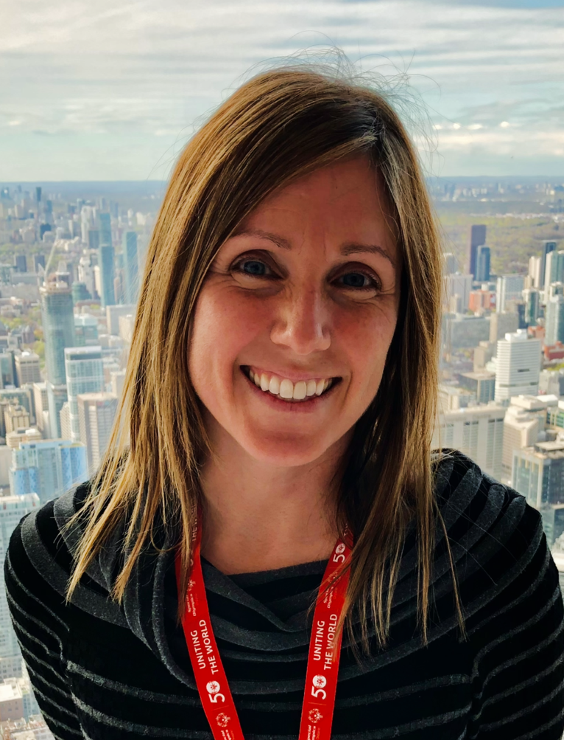 | Kelly is a Professor in the Faculty of Kinesiology and Physical Education at the University of Toronto. She is also a Board Member of Outdoor Play Canada and an Associate Editor of Adapted Physical Activity Quarterly. Situated within the field of behavioural medicine, her research program aims to enhance the health and well-being of disabled children through the provision of equitable physical activity opportunities. Kelly co-Chairs the CDPP Active Play Team with Dr. Jennifer Leo.

Basset-Gunter, Rebecca (She/Her)
Online Facilitator

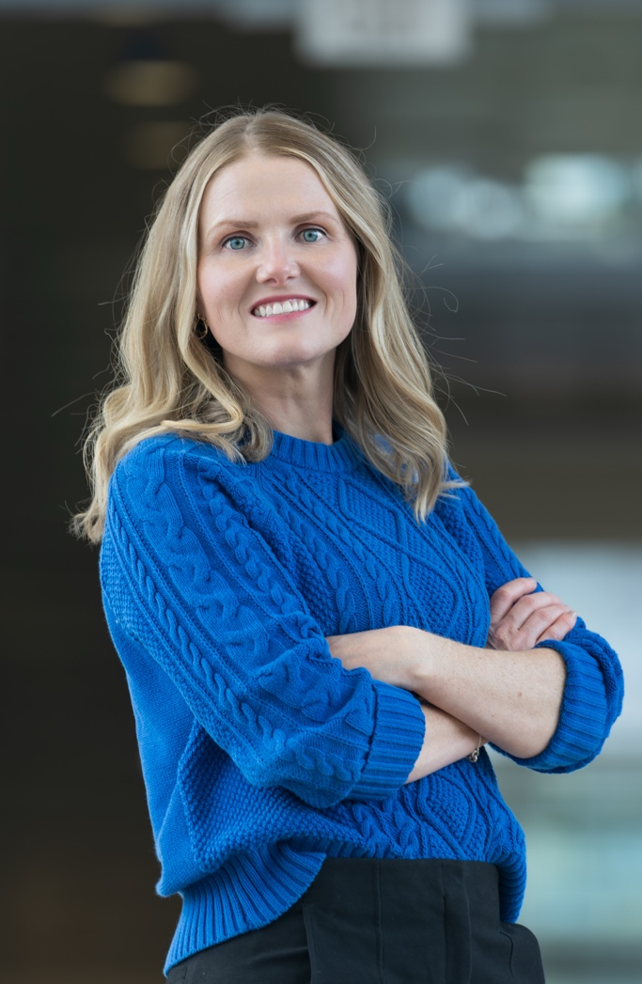 | Rebecca Bassett-Gunter is a Professor in the School of Kinesiology and Health Science at York University. She is the Director of the LaMarsh Centre for Child and Youth Research within the Faculty of Health at York. Rebecca is the Lead of the Dissemination and Implementation team for the Canadian Disability Participation Project 2.0. Her research is focused on strategies to promote and support quality physical activity for children and youth with disabilities. She is particularly interested in community partner-engaged research that can serve as a catalyst for knowledge dissemination, implementation and impact.

Gainforth, Heather (She/Her)
In-Person Facilitator
 | Dr. Gainforth is an Associate Professor in the School of Health and Exercise Sciences, Principal Investigator (PI) in UBC’s Centre for Health Behaviour Change, and a PI and Associate Director of Meaningful Engagement in the International Collaboration on Repair Discoveries (ICORD). As a behavioural and implementation scientist specializing in research partnership and knowledge mobilization (KM), Dr. Gainforth conducts and mobilizes high-quality, meaningful research that advances the science and practice of behaviour change and coproduction and builds capacity through training diverse research leaders.  Dr. Gainforth’s commitment to and leadership in partnered research helped to establish the international and award-winning SSHRC-funded partnership that co-developed the Integrated Knowledge Translation (IKT) Guiding Principles for Conducting and Disseminating SCI Research in Partnership (www.IKTprinciples.com). These principles have been highly cited, formally adopted by established research teams and funding organizations, and cited in the Lancet as a ‘powerful approach for ensuring research findings are relevant, useful, and used’. The eight principles and over 20 tools to support their use are foundational contributions as they provide a framework for supporting research that is impactful, ethical, inclusive, and relevant to research users.

Amy Latimer-Cheung (She/Her)
In-Person Facilitator
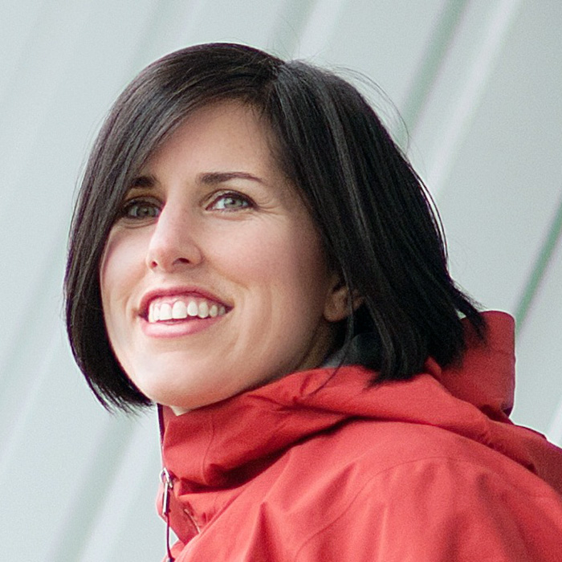 | Dr. Latimer-Cheung is a Professor in the School of Kinesiology and Health Studies at Queen’s University. Her research focuses on creating and mobilizing research knowledge to promote quality physical activity experiences for persons with disabilities. Amy is ranked internationally among the top researchers in productivity and impact according to the AD Scientific Index. Over her career, Amy has published extensively in peer-reviewed journals and secured substantial funding from Canada’s three major agencies as well as the NIH. She currently holds a SSHRC Partnership Grant—the largest funding opportunity in the social sciences within Canada. She is a member of the Royal Society of Canada’s College of New Scholars, a distinction given to scholars emerging as intellectual leaders in Canada. The practical research products she and her team have developed have been translated into multiple languages and accessed globally. Amy is also the founding and current Executive Co-Director of Kingston Revved Up, an exercise program supporting adults experiencing disability. She is a long-standing member of the ParticipACTION Research Advisory Group, which helps shape the Canadian physical activity agenda. Dr. Latimer-Cheung has accomplished these professional milestones while juggling the personal demands of being a partner, primary caregiver of young children, and daughter of aging parents.

Leo, Jen (She/Her)
Online Facilitator

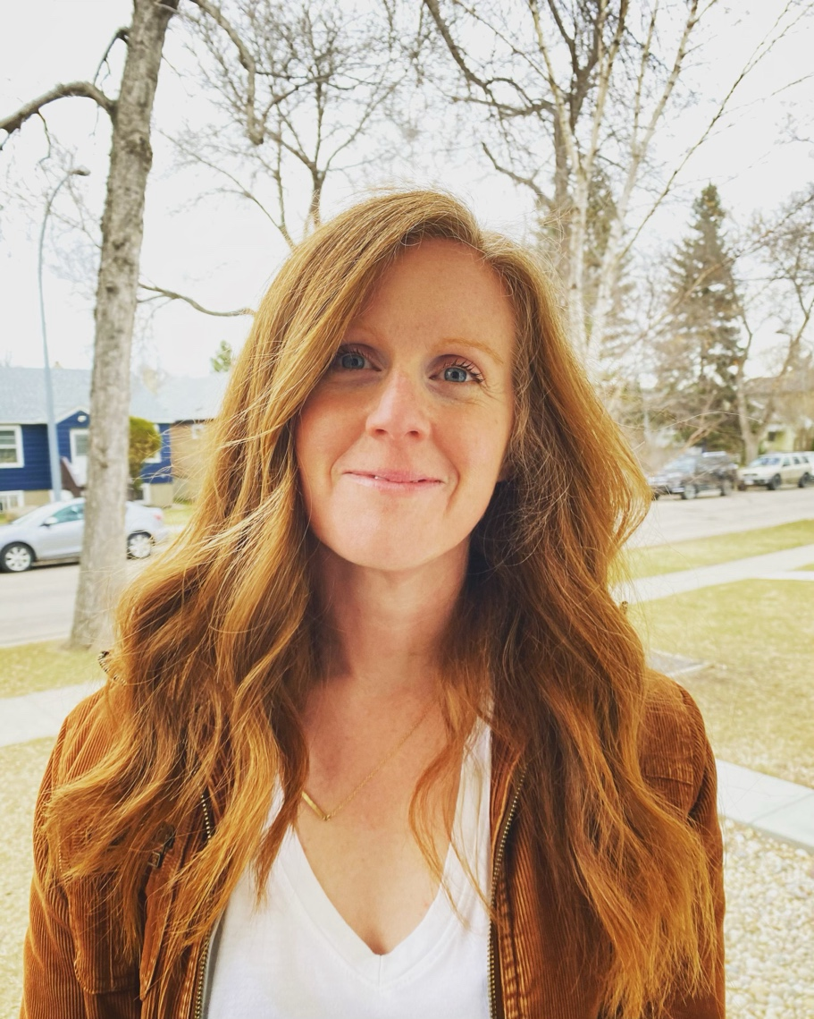 | Jennifer Leo, PhD is the Director of The Steadward Centre for Personal & Physical Achievement in the Faculty of Kinesiology, Sport, and Recreation at the University of Alberta. With over 15 years of research and community-based experience, Jennifer has focused on understanding experiences of access, inclusion, and participation in adapted physical activity settings. Jennifer prioritizes learning from those with lived experience of disability and she is committed to developing and supporting young people experiencing disability to become leaders and coaches in the community. Collaboration and partnerships are critical to Jennifer as she is a Co-Director of the Active Play Team in the Canadian Disability Participation Project and is a Member of the Leadership Team for the Inclusive Sport and Recreation Collective in Alberta.

Sukhai, Mahadeo (He/Him)
In-Person Facilitator

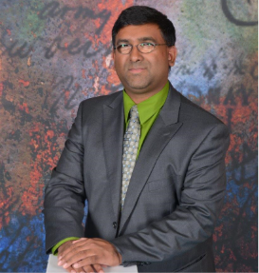 | Dr. Mahadeo Sukhai holds adjunct faculty appointments at Queen’s University, OCAD University, and the University of Ontario Institute of Technology, and is a nationally recognized expert in accessibility, systemic ableism, and anti-ableist practices. Dr. Sukhai has more than 20 years’ experience as an accessibility and inclusion professional, and as a researcher within this space, as well as more than 25 years’ experience as a scientist, researcher and educator in the medical sciences and healthcare related disciplines. Dr. Sukhai is a leading expert on accessibility of postsecondary education and employment for persons with disabilities. Dr. Sukhai is one of the originators of the discipline of and discourse on accessibility and inclusion in the sciences and in healthcare.

Presenters

Gainforth, Heather (She/Her)

Dr. Gainforth is an Associate Professor in the School of Health and Exercise Sciences, Principal Investigator (PI) in UBC’s Centre for Health Behaviour Change, and a PI and Associate Director of Meaningful Engagement in the International Collaboration on Repair Discoveries (ICORD). As a behavioural and implementation scientist specializing in research partnership and knowledge mobilization (KM), Dr. Gainforth conducts and mobilizes high-quality, meaningful research that advances the science and practice of behaviour change and coproduction and builds capacity through training diverse research leaders.
Dr. Gainforth’s commitment to and leadership in partnered research helped to establish the international and award-winning SSHRC-funded partnership that co-developed the Integrated Knowledge Translation (IKT) Guiding Principles for Conducting and Disseminating SCI Research in Partnership (www.IKTprinciples.com). These principles have been highly cited, formally adopted by established research teams and funding organizations, and cited in the Lancet as a ‘powerful approach for ensuring research findings are relevant, useful, and used’. The eight principles and over 20 tools to support their use are foundational contributions as they provide a framework for supporting research that is impactful, ethical, inclusive, and relevant to research users.

McColl, Mary Ann (She/Her)

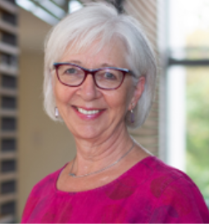 | Dr. Mary Ann McColl is a Professor Emerita in the School of Rehabilitation Therapy and Senior Scientist at the Health Services & Policy Research Institute at Queen’s University in Kingston, Ontario, Canada.  She has a PhD in Epidemiology & Biostatistics from University of Toronto (1991); a MHSc in Community Health & Epidemiology from University of Toronto (1983); a MTS in Theological Studies from Queen’s (2007); and a BSc (Hons) in Occupational Therapy from Queen’s (1978).  Dr. McColl taught foundational courses in occupational therapy theory and disability studies for 41 years. Her primary research areas include: disability policy, long-term health & spinal cord injury, spirituality & disability, and occupational therapy theory.

Nixon, Stephanie (She/Her)

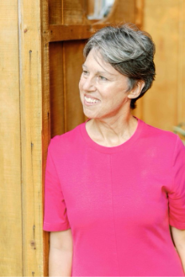 | Dr. Stephanie Nixon is Vice Dean (Health Sciences) and Director (School of Rehabilitation Therapy) at Queen’s University in Kingston, Ontario. She completed her PhD in Public Health in 2006 at the University of Toronto, and a post-doc at the University of KwaZulu-Natal in South Africa in 2008. Stephanie is a straight, white, middle class, able-bodied, cisgender, settler woman who tries to understand the pervasive effects of privilege. Stephanie developed the Coin Model of Privilege as a way to translate core ideas about anti-oppression to people in positions of unearned advantage like herself. She has conducted workshops on the Coin Model with more than 100 groups including universities, hospitals, community-based organizations, and professional associations across Canada and internationally. Stephanie and her collaborator, Tecumseh/Dr. Ed Connors, share their resources at www.futurebuilding.global.

Price, Jenson (She/Her)

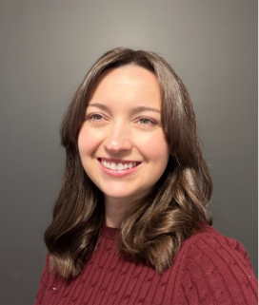 | Dr. Jenson Price holds a PhD in Human Kinetics from the University of Ottawa, where her dissertation explored how yoga supports self- and relational wellbeing among gynecologic cancer survivors. She is currently a SSHRC-funded postdoctoral fellow at Queen’s University, contributing to the mentorship stream of the Canadian Disability Participation Project 2.0 by identifying promising practices for promoting anti-ableism in kinesiology programs. Her research program is focused on advancing equitable, community-based interventions that promote wellbeing across diverse populations. Her work integrates behavior change theory, co-creation methodologies, and inclusive design principles to address systemic barriers to participation.

Sukhai, Mahadeo (He/Him)

Dr. Mahadeo Sukhai holds adjunct faculty appointments at Queen’s University, OCAD University, and the University of Ontario Institute of Technology, and is a nationally recognized expert in accessibility, systemic ableism, and anti-ableist practices. Dr. Sukhai has more than 20 years’ experience as an accessibility and inclusion professional, and as a researcher within this space, as well as more than 25 years’ experience as a scientist, researcher and educator in the medical sciences and healthcare related disciplines. Dr. Sukhai is a leading expert on accessibility of postsecondary education and employment for persons with disabilities. Dr. Sukhai is one of the originators of the discipline of and discourse on accessibility and inclusion in the sciences and in healthcare.

Tomasone, Jenn (She/Her)

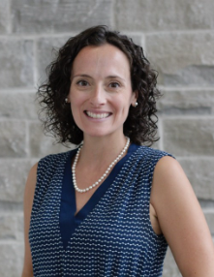 | Dr. Tomasone is an Associate Professor in the School of Kinesiology and Health Studies at Queen’s University. Blending her formal training in both exercise behaviour change and knowledge translation, Dr. Tomasone’s theory-driven program of research aims to close the gap between research and practice to optimize physical activity participation for persons of all abilities. She recently led the most comprehensive knowledge translation effort in the 40-year history of movement guidelines in Canada and now consults with international physical activity guideline groups, including the World Health Organization. She is also driven to optimize positive participation experiences in community-based exercise programs for persons with disabilities. She brings her research to life as a Co-Director of Revved Up, an exercise program for adults with a disability in Kingston, Ontario. As part of the Canadian Disability Participation Project (CDPP), she established a national community of practice which brings together community-based exercise program providers from across Canada to share best practices for fostering full and effective exercise participation for persons with disabilities. She also contributes to building capacity among CDPP members to carry out this work through initiatives such as the CDPP 2.0 Summer Institute and the CDPP 2.0 Kinesiology Curriculum Scan. Outside of work, Jenn enjoys cooking, spinning, yoga and being active outdoors with her family and friends.

Planning Committee

Gee, Christina (She/Her) | Price, Jenson (She/Her)
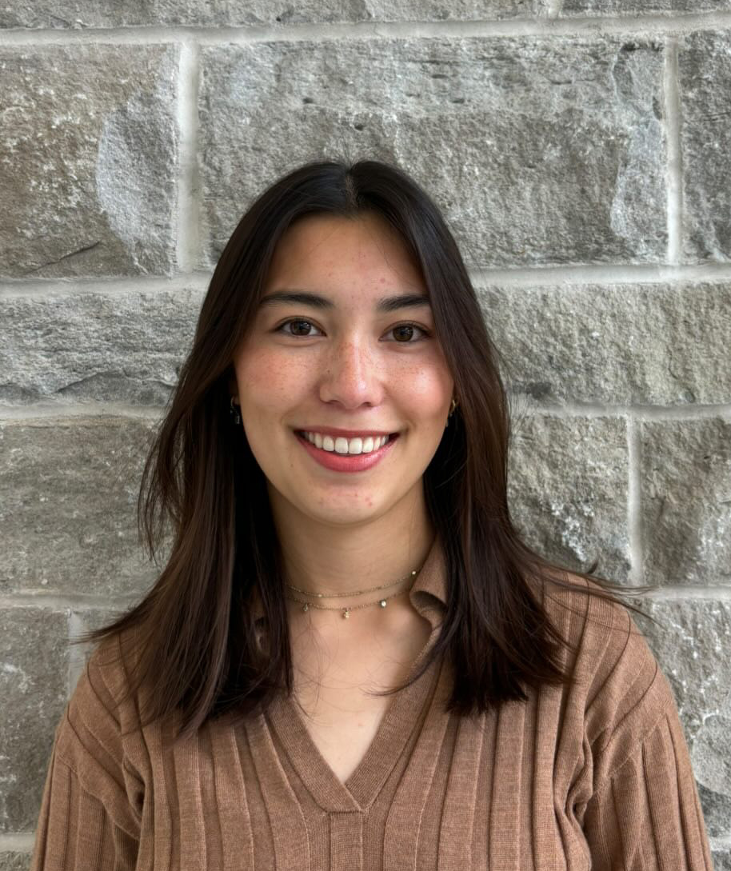

Robinson, Samantha (She/Her) | Sukhai, Mahadeo (He/Him)
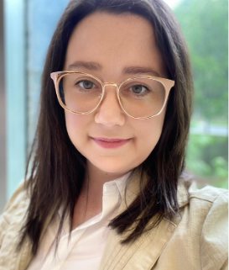

Tomasone, Jenn (She/Her) | Van Dornick, Kirsti (She/Her)
 | 

